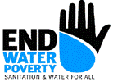
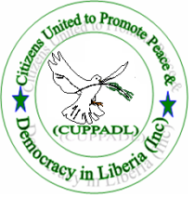
Looking Back, Moving Forward: Key demands
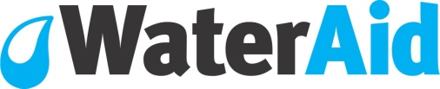
for Achieving Sanitation and Water for all
Through the Millennium Development Goals
(MDGs) and the Post-2015 Framework

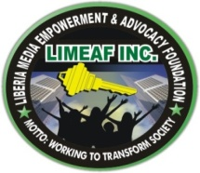

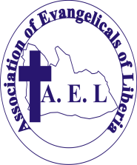
LIBERIA NGOs NETWORK, INC.
LINNK

“Every target of the MDGs depends on the achievement of the water and sanitation target”

WASH: value for money globally

Every $1 invested in sanitation returns $4 in increased productivity

Estimated total economic losses from inadequate water supply and sanitation services are $260 billion a year

To achieve the MDG target on sanitation by 2015, an estimated $32.2 billion in funding would be needed from 2010 – 2015

Lack of safe water and sanitation costs sub-Saharan Africa around 5% of its annual GDP

Hygiene promotion could save an estimated 333 disability-adjusted life years (DALYS) for every $1,000 spent
Water, sanitation and hygiene (WASH) are central to sustainable economic and social development, the achievement of the MDGs, and the success of the post-2015 framework which will determine a new era of official sustainable development policy and practice. More than 1 million people worldwide have signed a petition calling on leaders to keep the promises they have already made on WASH. In the UN MY World survey, 800,000 people across 194 countries selected water and sanitation as one of the top five issues that, if addressed, would make the most difference to lives.

Mixed progress on MDGs

The water MDG target has been reached, but this global achievement is tainted by severe regional inequalities: almost 40% of people in sub-Saharan Africa – some 800 million people - still lack access to safe water. 1.2 million Liberians use unsanitary or shared latrines; 1.7 million have no latrine at all and defecate in the open. The poorest quintile is almost 7 times more likely to practice open defecation than the richest. Open defecation costs Liberia US$11 million – yet eliminating the practice would require less than 350,000 latrines to be built and used. Approximately 3,000 Liberians, including 1,800 children under 5, die each year from diarrhea – nearly 90% of which is directly attributed to poor water, sanitation and hygiene (WASH). In addition poor sanitation is a contributing factor – through its impact on malnutrition rates – to other leading causes of child mortality including malaria, ALRI and measles.

The MDG sanitation target is the most off-track of all the MDGs. At current rates of progress it will take until 2026 to reach the target at a global level, while in sub-Saharan Africa where Liberia is it could take two hundred years to reach. Indeed, when accounting for population growth, as many people are without basic sanitation today as there were in 1990.

End Water Poverty is a global coalition of more than 260 civil society organizations and the Liberia CSOs WASH Network is a national network of more than six civil society organizations and five counties chapters they both are campaigning in partnership to end the water and sanitation crisis. It calls for a substantial increase in resources from both donor and partner countries in line with what is required to achieve the MDGs.

WASH and the post-2015 development framework

End Water Poverty and the Liberia CSOs WASH Network call for the post-2015 development framework to include:

WASH: value for money

Liberia loses 17.5m USD annually due to poor sanitation
(WSP 2010)

US$4.9 per person in Liberia per year or 2.0% of the national GDP is lose due to poor sanitation
(WSP 2010)

Current sanitation investment in Liberia is less than 0.1% GDP which is lower than several estimates for what is required
(WSP 2010)
A goal explicitly focused on water, recognizing the centrality of WASH to the economy, health, gender, education and environment sectors. WASH targets and indicators must address access in households, schools, health facilities and workplaces, and incorporate mechanisms to reduce inequalities and prioritise the poorest and most vulnerable communities.

The Liberia CSOs WASH Network particularly calls for:
- The Government of Liberia delegate to the UN General Assembly to lobby member countries and governments of the UN at the General Assembly pending for September 2013 to prioritize water, sanitation and hygiene in the post 2015 development frameworks
- The government of Liberia delegation to ensure that the recommended water and sanitation targets as made in the high Level Panel Report to be discussed are maintained and expanded to include targets for access to water and sanitation in especially marginalized communities
- The government of Liberia through the national legislature to ensure Liberia meet the eThequini declaration by allocating budget lines in the national budget 2013/2014 for WASH
- The government of Liberia to begin taking steps that will lead to the establishment of a water, sanitation and hygiene ministry as this is a best practice across the world in an effort to unify water, sanitation and hygiene governance for better targeting, service and standard

For more information, contact:

End Water Poverty
Tel: +44 (0) 207 793 4960
Email: esmeerussell@endwaterpoverty.org
Registered charity numbers: 288701 (England and Wales) and SC039479 (Scotland)

Liberia CSOs WASH Network
Tel: +231886533015
Email: cuppadlinc@yahoo.com

The future framework must be designed to protect, respect and realise of the human right to water and sanitation now widely recognized by UN member states. This right must frame the definition of access to WASH. The framework must also account for the impacts on the WASH sector of population growth and adaptation and resilience to climate change, and the extra focus this necessitates on the need for sustainable use of water through responsible and sustainable water resources management.
UN Global Issues. Available online [accessed 06/08/13]: http://www.un.org/en/globalissues/water/ Hutton, G (2012) Global costs and benefits of drinking-water supply and sanitation interventions to reach the MDG target and universal coverage, p4. World Health Organization, Geneva. Ibid, pp5-6 Ibid, p5 Human Development Report 2006, Beyond scarcity: Power, poverty and the global water crisis. United Nations Development Programme. WaterAid (2013) Everyone, everywhere: A vision for water, sanitation and hygiene post-2015. WaterAid, London, UK. The petition is a part of the Keep Your Promises campaign. For more information, visit: http://www.keepyourpromises.org/ Survey results available online [accessed 07/08/13]: http://www.myworld2015.org/?page=results World Health Organization, UNICEF Joint Monitoring Programme (JMP) (2012) Progress on Drinking Water and Sanitation: 2012 Update, p.5. Available online [accessed 07/08/13]: http://www.unicef.org/media/files/JMPreport2012.pdf Ibid p15 WaterAid calculations based on World Health Organisation, UNICEF Joint Monitoring Programme (JMP) statistics 2.4 billion people were without access to sanitation in 1990, compared with 2.5 billion in 2010. See World Health Organization, UNICEF Joint Monitoring Programme (JMP) (2012) Progress on Drinking Water and Sanitation: 2012 Update, p15.

