Citizens United to Promote Peace & Democracy in Liberia (CUPPADL)
Upstairs Jetty Trading Corporation Building
Airfield Short-Cut Junction
24th Street
Sinkor
Monrovia, Liberia

Annual
Activities Report

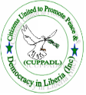

Period
Contact Us
Cell: +231-886-533-015
+231-886-582-878
+231-880-432-605
+231-886-233-254
+231-880-727-429
Email: cuppadlinc@yahoo.com
January to December 2015
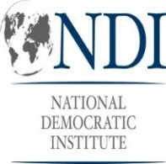
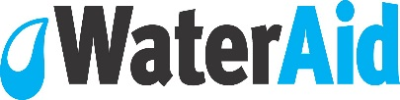
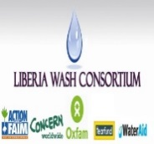

1.0 Introduction
Liberia is slowly recovering from civil war 1989-2003 which witnessed widespread damaged of infrastructures, slow basic social services such as water, sanitation, hygiene, electricity, education, general health etc. additionally, peace, security, justice and human rights situation was badly injured thus leading to the population adopting the posture of taking the law in their hands when they feel aggrieved.

The Poverty Reduction Strategy (PRS), Liberia Demographic Health Survey and other reports estimates inadequate access to safe drinking water, human waste collection and disposal facilities, health care, justice, protection under the law etc.

Since the climaxed of the war in 2003, citizens actions and engagement of public officials to improve service quality and access in other social sectors have gained momentum and service quality and access in these social sectors such as education, road constructions have improved. Citizens engagement of their elected and appointed officials who have the primary responsibility to improve access to basic services, human rights redress mechanisms, policy implementation and formulation was still slow by 2014 as the result of which significant proportion of the population as intimated above was lacking basic services, infrastructures, peace and security etc.

In an effort to mobilize civil society and citizens voices aim at engaging and to hold relevant public officials to take the appropriate action aim at improving access to social services, promote peace and security thereby reducing poverty, the CUPPADL has and continue to partner with national and international organizations to lead advocacy and engagement efforts at the national and sub national levels.

The CUPPADL partnership and advocacy initiatives have been pursued through networking with likeminded organizations and networks including the Liberia CSOs WASH (Water, Sanitation and Hygiene) Network, Maternal and Newborn Health CSOs Advocacy Working Group and the National Budget and Human Rights Forum. These organizations and CUPPADL strongly subscribe to the believe that given the devastating effects of the civil war on Liberia’s human and economic development, a coordinated approach to advocacy has the potential to put forth real effective citizens driven advocacy that could potentially speed the implementation of the government’s Agenda for Transformation, Vision 2030 and the realization of the Millennium Development now Sustainable Development Goals water and sanitation targets.

To this end, the CUPPADL and partners have mobilized funding from several international organizations to implement advocacy and engagement action at addressing the problems mentioned previously. This report will therefore inform its readers, the donors and the people of Liberia and the world about action taken in 2015 by the CUPPADL to accelerate government and other stakeholders’ action to end the social problems, promote peace and sustain security in Liberia. The report content include the problems, activities implemented by the CUPPADL, target set for which activities were implemented, location of activities, timeline and venue, lessons learnt, challenges experienced in project activities implementation and recommended action for the way forward.

Vision
The vision of the CUPPADL is a Liberia where every person can access basic social services as well the space is provided for direct citizens role in policy formulation, implementation; development planning and public finances are directed for the goods of the population in a manner that promotes individual and general development.

Mission:
The mission of the CUPPADL is to contribute to the development of Liberia through supporting poor, marginalized, vulnerable groups to access basic social services and built the capacity of civil society and local government to input into policy processes, democracy and peace building initiatives using human rights based and pro-poor approaches.

5.0 Activities Implemented
Activities implemented aim at addressing the problems as mentioned in the introduction and to contribute to the attainment of the Vision, Mission and specific objectives of the CUPPADL included the following:
- Montserrado, Bomi and Margibi Counties Ebola Response Orientation Training
- Bomi, Margibi and Montserrado Brainstorming Sessions and Plan Launch
- Two community post Ebola feedback meetings in three counties;
- Five counties stakeholders dialogues;
- 30 lobby meetings;
- Sit-In-Action at Liberia Water and Sewer Corporation
- Follow-up Meeting to LWSC Sit-In-Action
- Sit-In-Action at MLME, MOH, MFDP and MOPW
- Health Facility WASH Assessment Orientation and Assessment
- Ebola Response Team Transformations into WASH Committee and Training
- Four Legislative Investigation Mission;
- Evaluation of Liberia Sanitation and Water for All Statement of Commitment
- Observe Global Events (World Water Day, World Toilet Day and Global Hands Washing Day)
- Media campaign;

5.1 Montserrado, Bomi and Margibi Counties Ebola Response Orientation Training: On January 3, 2015, the CUPPADL as the host of the Liberia CSOs WASH Network with funding support from the National Democratic Institute (NDI) and the Swedish Embassy near Monrovia held one day orientation Training for twenty eight animators drawn from the four communities in Montserrado County including the Chicken Soup Factory, Snow Hill, Bassa Town or River View and Swagger Island. Similar training took place at separate dates in Margibi, Dolo’s Town and Bomi, Vai Town respectively. The training in the two communities participants sum up to fourteen (14). The orientation training started from 9:15am and ran to 5pm, participating animators were recruited from the youth leadership, women leadership, community leadership and Community Based Organizations.

The purpose of the orientation was to deepen the understanding and skill animators in the use of various tools, awareness creation measures and strategies available for effectiveness in the communities Ebola responses. Three facilitators from the Ministry of Health delivered lessons in three areas including contact tracing, awareness creation methodology, use of thermometer and other anti Ebola materials and tools.
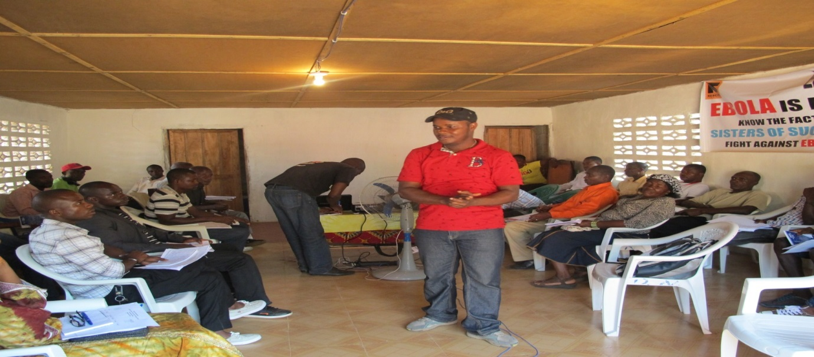
One of three Trainers Presenting @ Montserrado Orientation

At the end of the training session, the animators were divided into four (4) groups to discussed and report back to plenary what they learned in training.

The groups reported back as followed:

- History of the Ebola Virus Disease. The first outbreak was in Zaire, DR. Congo in September 1976 by a Microbiologist and Scientist name Dr. Peter Pioh from Belgium Ebola does not have cure but rather symptomatic treatment
- Host of Ebola include Monkeys, Bamboos, Fruit Bats and Gorillas
- Mode of transmission includes bodily fluid from affected person such as saliva, sweat, vomit urine etc.
- Shaking affected person hands
- Physical contact with affected Ebola person
- Eating bush meat
- Challenges includes denial, home treatment, secret burial of infected person, Traditional/cultural practices and fear
- The used of chlorine which includes 0ne (1) table spoon =five (5) liters and the duration is for twenty-four hours (24hrs). two type of chlorine the high concentrated -0.5% and the low concentrated 0.05%
- PPE is for burial team, case investigators, and at the Emergency Treat Unit (ETU)
- 4455 who to contact Awareness raisers (Community Ebola Response team/ contact tracers ), , Supervisors/case investigators, and Red Cross when the person is dead
- Investigation of cases: suspected no history of contact, Probable- history of contact and confirm laboratory test positive of Ebola Virus
- Purpose of contact tracing: to avoid the spread of the Ebola Virus, for monitoring of person/ people for signs and symptoms who have history of Ebola for early treatment

Each of the facilitators had over two hours to present their lessons, participants had the opportunity to make inquiries to satisfy their and others comprehension of the lessons content. Several materials were distributed to animators during and at the end of the training. During the training materials given them included the facilitators presentations, note pads, pens, anti-Ebola flyers and materials distributed after the training included T-shirt, batches marked with their names, reporting forms, pens, note pads, etc to facilitate their door to door outreach.

5.2 Bomi, Margibi and Montserrado Brainstorming Sessions and Plan Launch: In January 2015 the CUPPADL as host of the Liberia CSOs WASH Net with support from the National Democratic Institute (NDI) and the Swedish Embassy near Monrovia held one day Brainstorming session on Ebola response each in the Vai Town Community in the Vincent Compound in Tubmanburg Bomi County, Dolo Town Hall, in Margibi, Gardnersville Town Hall in Montserrado County. Each of the three sessions started from 9:15am and ran up to 4:15pm with twenty two (22) persons in attendance in each session including youths, women, Development Superintendent, and the community leadership.

The purpose of the meeting was to brainstorm and document on how the deadly Ebola Virus spread in the community, challenges faced by the community in the fight against the deadly Ebola Virus, how the community intend to engage their legislators in the fight against the deadly Ebola Virus, and support areas needed to eradicate the Deadly Ebola virus out of the Vai Town community and beyond.
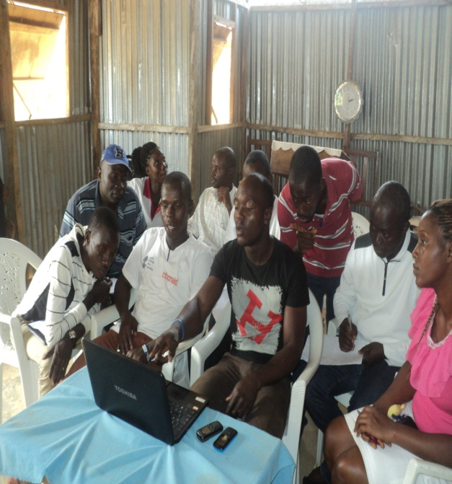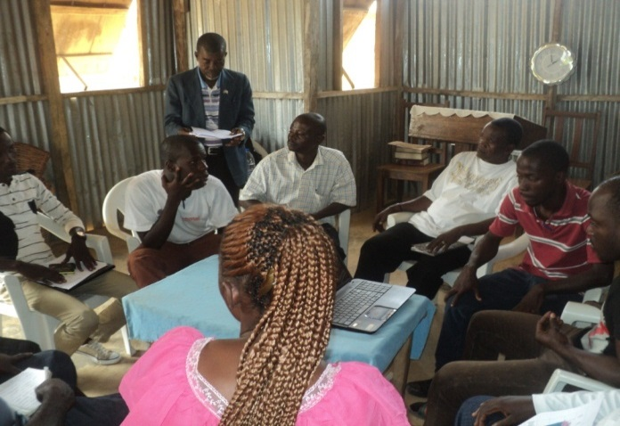
Participants Developing Plan Participants Developing Plan

The selected animators and community dwellers were cluster into group, during which time they gather data to inform their community Ebola situation analysis and developed detail community Ebola Response Plan for their community. Each community plan identified resources available, resources needed from partners, sources of resources, time line for the implementation of each activity, activity to be implemented for the attainment of objective etc. Additionally, community Ebola response situation analysis answered such questions as method of Ebola spread in the community? Strategy/activities to prevent and stop the spread of Ebola in the community; active structure and existing action taking place or have happened in the community; activities done in the community to stop the spread of the Ebola; areas of support needed; method of gender integration; and legislative engagement.

In January 2015, the Liberia CSOs WASH Network launched each of the communities Ebola Response Plan in an elaborate program attended by various stakeholders drawn from government, civil society, the media and legislature. Each launch started from 9:15am and ran to 11am with over 30 people in attendance including youth leaders, women leaders, Development Superintendent, Commissioner, Market women representative, community leadership, CSOs organizations, CBOs, and the Media.

The purpose of the launch was to generate public support in the communities for the Ebola Response Detail plans and activities.

5.3 Post Ebola Impact Assessment Meetings
Over the period of 2015 two post Ebola impact assessment meetings were held in Montserrado. As part of the two meetings, one Post Ebola Impact Assessment meetings were held in each of two communities in Mountserrsdo, June 16, 2015. Those communities included Snow Hill community and Chicken Soup Factory Community.

The objective of the Post Ebola Impact Assessment Meetings was to identify challenges and , impacts of the communities Ebola response with the desire to inform decision leading to maintaining the team in its current state while establishing WASH Committees or mandate. During each of the Post Ebola Impact Assessment Meetings, communities Ebola response teams reported challenges and impacts of their Ebola response, the reports of the various communities were discussed and way forward agreed.. Also during those meetings agreement between the Liberia CSOs WASH Network and the communities were reach and agreed to be documented in a memorandum of understanding to be drafted by the network and signed by both parties. At each meeting the content of the memorandum was discussed and agreed to be included in the MOU.

At the end of each of the two Ebola Response Assessment meetings in the two communities, some sanitation materials including Wheel barrows, Shovels, Cutlasses and Wipers were distributed to communities as a starter in other to enhance their capacity.
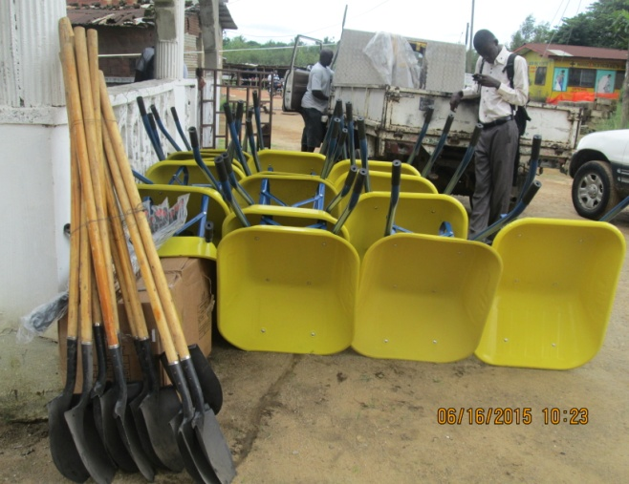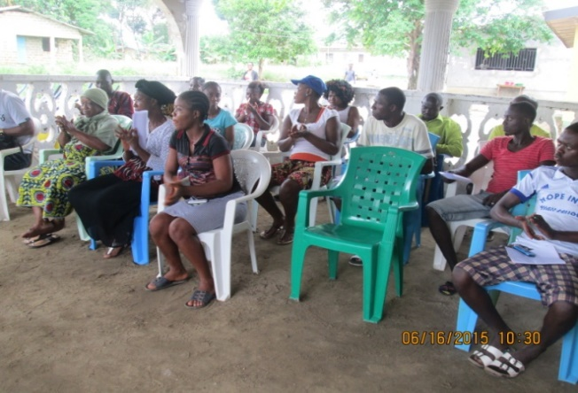

5.4 Stakeholders Dialogue on WASH:
Over the Period of 2015 five (5) counties water, sanitation and hygiene Stakeholders dialogue were held in Nimba, Sinoe, Grand Cape Mount, Maryland, Montserrado. Sixty (60) to seventy (70) stakeholders drawn from women, youths, community leaders, local governments and county legislators were in attendance at each of the dialogues. These meetings created the platform where policy makers from local, legislator and national levels met face to face with citizens groups discussed, reached agreement towards improving access to WASH and governance.
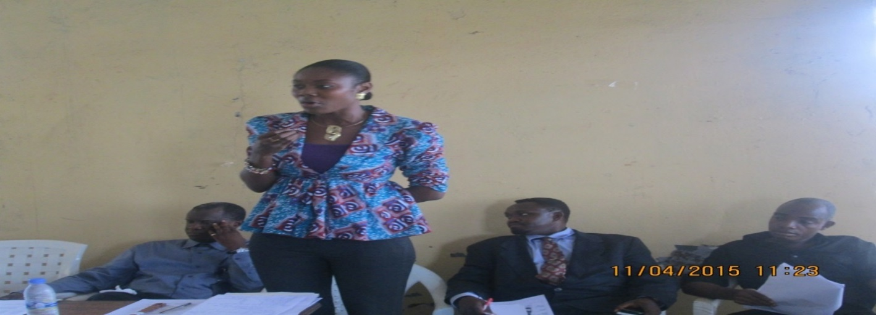
Rep. Pelhm presenting while LWSC MD, Charles Allen and Proxy of Senator Doe look on

The stakeholder’s dialogues pattern of organization created space for Liberia CSOs WASH network to make presentation on their awareness of the six cities water system, the previous stakeholders meetings in the counties and wash problems while suggesting the way forward to addressing those identified problems. Additionally, the Liberia Water and Sewer Corporation was requested through its county chapters in the two counties to present to the dialogue the status of the restoration of the city water systems outlining challenges, prospects and opportunities of the cities systems completion on time. For their part the local authorities were requested to present their awareness of the status of the cities water system and action taken by them to improve WASH in their counties.

Following these presentations, the participants of the five counties water, sanitation and hygiene stakeholders were split into three groups each where each group discussed identified issues and reached recommended points aim at improving access to water, sanitation and WASH governance. The various groups had the opportunity to presented their findings to plenary after which plenary adopted and mandated the CUPPADL to develop a county WASH policy paper for onward presentation to the legislative caucus, local county authorities, the national government and the press for the required action. Additionally, it inform consolidated policy paper presented to the House of Representatives committees responsible for water, sanitation and hygiene during the public hearing.
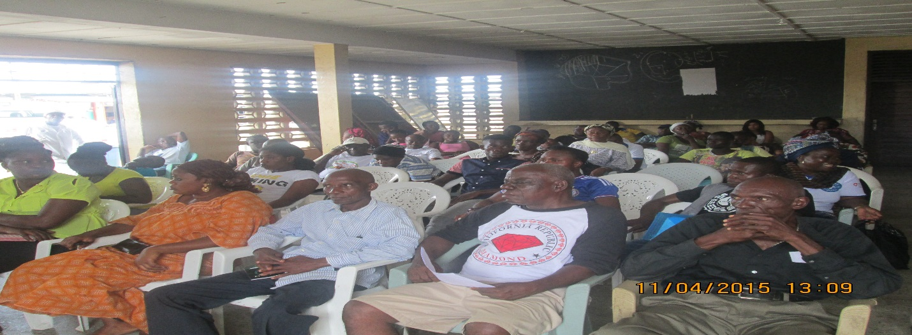
Participants of Clara Town, Montserrado Dialogue

5.5 Hold 30 Lobby Meetings with local Government, Legislators and Cabinet Officials
During the period under reviewed (2015) thirty (30) lobby meetings were held separately with selected legislators, local governments and cabinet officials of government. The objective of the meetings was to influence political actions from individual officials of government and the governmental structural aim at improving water, sanitation and hygiene service quality, access, governance and policy implementation.

Each of the meeting which took place in the offices of the officials met with lasted for at least 1 hour and at most 2 hours. A designated representative of the civil society delegation presented civil society issues to the official of government in oral and written one page document. At each meeting, following the presentation of civil society issues, the official of government had the opportunity to respond to the civil society issues raised.

Cabinet officials of government met with included Jackson Paye, Deputy minister of Public Works for Rural Development, Liberia Water and Sewer Corporation Managing Director Charles Allan, Deputy minister Lands mines and Energy, Chief Medical officer of Liberia, Dr. Francis Ketter, etc. Legislators visited included Senator Daniel Nathan of Gbarpolu County, Geradine Doe Sheriff, senator Montserrado County, Oscar Cooper, senator Margibi county, Jim Tornola senator Margibi County, Emmanuel Nuquay representative Margibi County, Sekou Kanneh, Representative Montserrado county, Numinnie Bartekwa Representative Grand Kru County, Wesseh Blamo, representative Grand Kru county, Haja F. Saryon, representative Bomi County, while local governments visited included Bomi, Margibi, Maryland, Grand Bassa, Montserrado, Grand Kru, River Gee etc.
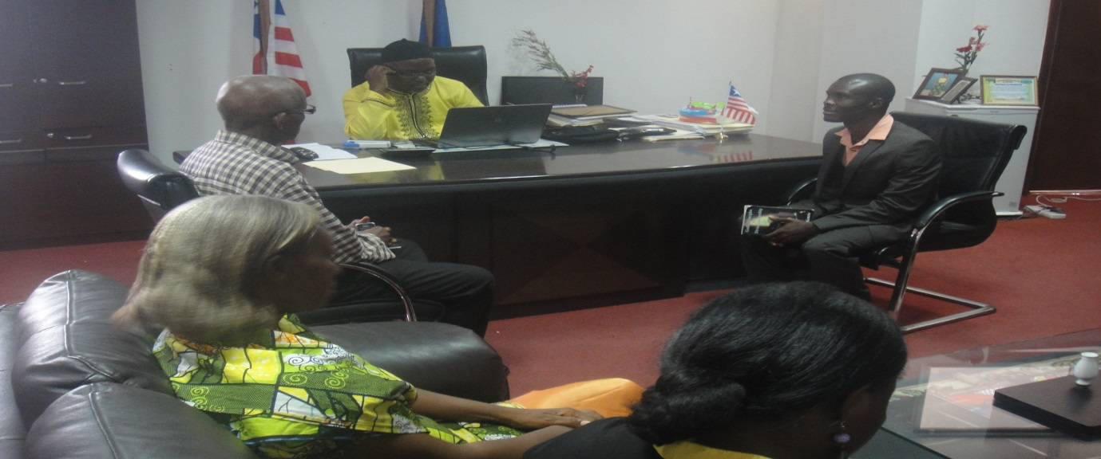
Deputy House of Rep Speaker, Hans Barchue and CUPPADL Delegation Charting

Issues Discussed with Legislators, Local Governments and Cabinet Officials Separate
During separate meetings with senators, member of the House of Representatives and executive officials civil society campaigners for right and access to water sanitation and hygiene discussed the 2014 Liberian Senate committee on Public Works public hearings on WASH draft report which have since been in committee room. The civil society campaigners members of the Liberia CSOs WASH Network appeal to the conscious of the lobbied senators and representatives to use their influence with the committee to ensure the committee report is submitted to the senate plenary for discussion and action.

A fact sheet that contains access level of various counties relative to water sanitation and hygiene content was disseminated to the senator and representatives met with the CUPPADL team. The fact sheet information included water sanitation access levels in schools and communities of the various counties and the country in general. The purpose of disseminating these data to legislators was to influence political interest in WASH and inform their legislative oversight on the executive agencies responsible for WASH governance, service provision, and service access and service quality.

Additionally, the WASH campaigners lobby meetings with legislators inform them about the president of Liberia and WASH Goodwill Ambassador for Africa mentioned of WASH in her 2015 state of the Nation address highlighting her mentioned of 67% of the country population having access to WASH and 33% without access, 15% of population having access to improve sanitation while 85% without access and 5% of the population practice safe hygiene while 95% does not. The campaigners used the occasion to inform or bring to the attention of legislators the president mentioned of six cities water systems restoration commencement by January 2015 after these systems according to the president restoration was halted due to the outbreak of the EVD. The campaigners lobby the legislators to regularly cite the Liberia Water and Sewer Corporation to update those (legislators) on the status of these systems restoration as mentioned by the president.

The campaigners also lobby legislators to demand integration of various sector issues including WASH in the post 2015 development agenda of Liberia and the globe while performing their oversight responsibility on the executive.
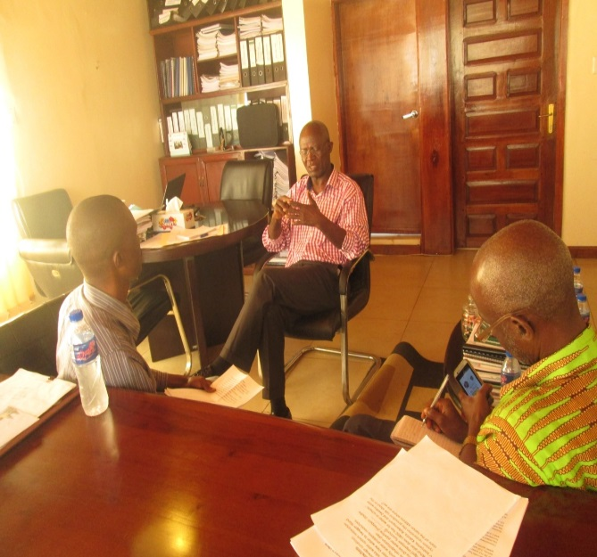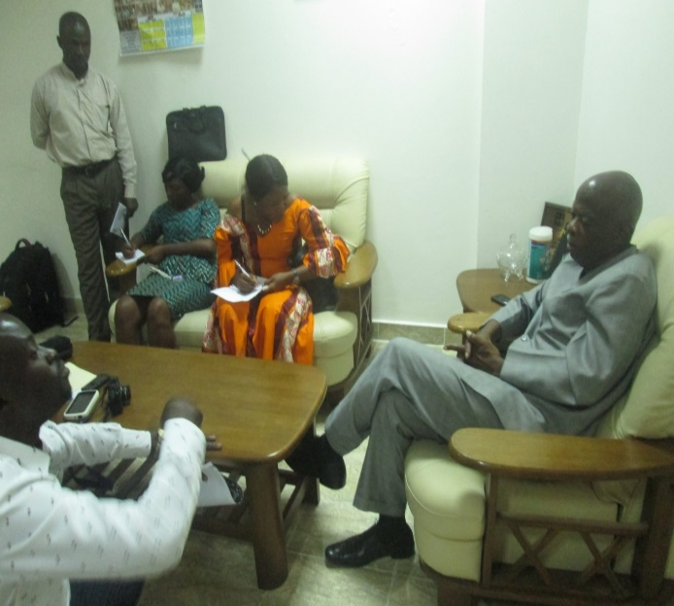
CSOs in Meet with LWSC Managing Director CSOs in Discussion with Senator of G. Cape Mount

5.6 Sit In Action at LWSC:
The CUPPADL on August 14, 2015 held a one day Rally/Sit-in- Action on ground of the Liberia Water and Sewer Cooperation (LWSC) compound. The Rally lasted for two hours started at 9:00 and ran up 4:00pm. The purpose of the sit in action is to demand public official to take concrete action on commitment made by them on WASH. The Objective was to put people at the center of advocacy with the aim to influence the operationalization of the Board and establishment of water sanitation and hygiene commission as the surest way of improving governance in the WASH Sector.
The Rally/Sit-in-Action at the Liberia Water and Sewer Corporation brought together fifty campaigners drawn from the Concerned Christian Community (CCC), Women NGOs Secretariat (WONGOSOL), Citizens United to Promote Peace and Democracy in Liberia (CUPPADL), Concerned Christian Community, New Hope Community, Swagger Island Community, Slip Way Community all in Montserrado.
At the petition rally the campaigners petition statement was read by one of the campaigner Kebeh Johnson. During the reading she outlines several actions that should be taken by the administration of the Liberia Water and Sewer Corporation petering to water supply in the country.
After reading the petition statement and received by the acting Managing Director madam Charlene Abla Awadjie-Ihedioha the leadership of the network requested an indoor meeting with the administration of LWSC which started at the conference room but later petitioner demanded their participation and the meeting venue was change to the parking lot which was spacious for everyone.
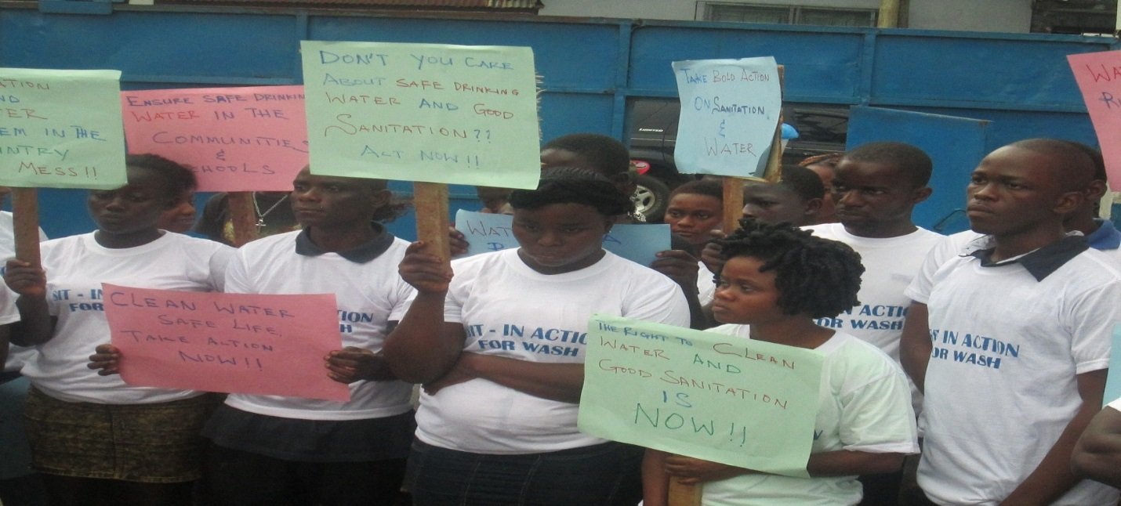
Campaigners Post with Placards at LWSC Offices in Monrovia

5.7 Follow-up to Sit-In Action Meeting:
On Thursday September 3rd, 2015 the CUPPADL convened meeting between the Liberia Water and Sewer Corporation (LWSC), National Transit Authority ((NTA), Zinc Camp and NTA Communities Leaderships. The meeting purpose was to resolve issues between the LWSC and NTA on one hand and the Zinc Camp and NTA Community on the other hand which lead to the shut of a water system done by JACA for water supply to the communities. Prior to its shut, the water system pumped water to the two communities through four supply unities of six forests each, the system was installed in the compound with a 48kva generator that supply power. Additionally, the system was run each day from 4am to 8pm, designated persons were running the kayos on a percentage cut basis. LWSC receives 28% of intake for restoration of the pumping machine in the event it is damage; selected trained kayos managers received 40% of intake as source of livelihood. The selected trained community dwellers designated to manage each kayos were less fortunate people that were unemployed and engages in sex trading and other unacceptable habits for livelihood.
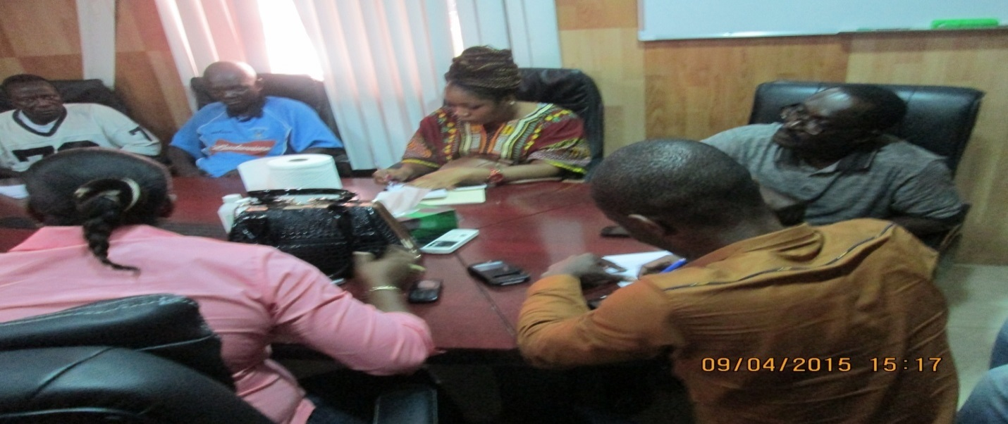
The community complains the NTA management to the CUPPADL alleging that the NTA for more than a year now the NTA has deny the population access to the system and had been using the water to wash their vehicles in the compound of the NTA.

The meeting which lasted for three hours 2-5:30pm reached the following resolution:
- That once LWSC desides to reopen the system and supply the community the NTA has no problem with that
- That CUPPADL will work with the community to check all the pipe lines for leakage and advise the LWSC
- NTA agreed to be responsible for the fuel supply as part of her cooperate responsibility to the community and because the water supply by the system is equally use by the NTA to wash their vehicles
- LWSC will improve on and ensure all parties resign new MOU that clearly defines various parties roles

In attendance were the Managing Director and three deputies of the National Transit Authority (NTA), two representatives of the Liberia Water and Sewer Corporation (LWSC), two representatives of the CUPPADL leadership and four representatives of the two communities.

5.8 Sit-In-Action at MOH, MFDP and MOPW

Over the period of the project activities implementation as part of agreement enter into with WaterAid three Sit-In Action/Rally was held on the grounds of three Ministries of the Government of Liberia including Ministry of Public Works, Ministry of Health, and Ministry of Finance and Development Planning.

The purpose of the sit in action was to demand public official to take concrete action on commitment made by them on WASH. The Objective was to put people at the center of advocacy with the aim to influence the operationalization of the WASH Board and establishment of Water Sanitation and Hygiene Commission as the surest way of improving governance in the WASH Sector.

In fulfillment of civil society civic responsibility four, Sit – In – Act were held at four different ministries named above on May 21 and 22, 2015. During each of the three sit in action overview of the meeting was performed, petition statement were presented to the ministers in the midst of a crowd of 90-100 identified with flyers and wearing t-shirts marked pro water and sanitation messages.

First Sit-In-Action At Public Works Ministry: As part of ensuring project activities objectives are met, the first sit in action was held on the grounds of the Ministry of Public Works on May 21, 2015. The Sit-In which lasted for three hours started at the presided hour of 9:00am and ran up to 12:00noon. The ceremony was attended by over fifty (50) people including women, youth, community leaders, members of the CUPPADL and the media.
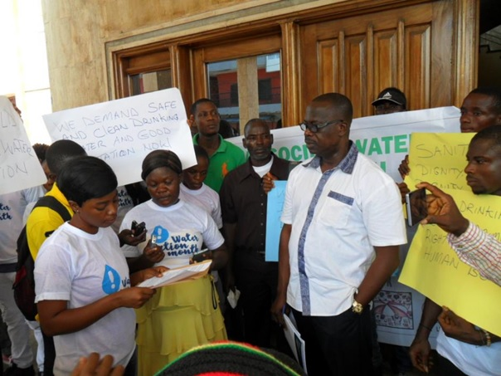
Petitioners presenting petition to Deputy Minister of Public Works

At the start of the ceremony on the arrival of the minister an overview statement was presented on behalf of the network by Alex Dweh one of the resident of the various communities that attended, during his overview he said the following:

- The sit in action is going to take place at four ministries responsible for WASH. These ministries include:
The ministry of Public Works, the Ministry of Lands, Mines and Energy, ministry of Health and the Ministry of Finance
- Mr. Dweh said that ahead of the May 26 conference in Dakar and the ninety days ultimatum given the government of Liberia on March 22, 2015 at the Sharvon Park during the celebration of World Water Day concerning improve WASH, and ahead of the conference the group have come to demand adequate safe drinking water, sanitation and hygiene.
- He said according to World Bank water and sanitation assessment report, the number of persons dying annually from lack of safe drinking water is very huge
- Public official and government needs to do something to improve the WASH sector of our country.

The 3rd Sit in Action At Ministry of Health and Social Welfare: The third Sit-In Action ceremony was held at the head office of the Ministry of Health and Social Welfare on May 22, 2015. The ceremony which lasted for three hours started at 10:00am and ran up to 2:00pm.The event was attended by over forty (40) people from different background such as: women, youth, community leaders, members of the CSOs WASH Network and the media.

At the Sit-In Action petitioner had the opportunities to display flyers with different messages in support of water, sanitation and hygiene. Petition also chanted slogan and song songs in support to WASH with the desire to draw WASH stakeholders attention. At the event as was the case of others, petition statement was delivered by petitioner to the Ministry leadership. The overview was done by Martina Gbarlar, the petition statement of the Sit-In participants was read similarly by one of the student Andrews D. Davis who dwells in the New Georgia community in Gardnerville. Attached to this report is the full statement.

The 4th Sit-In Action At Ministry of Finance and Development Planning: The fourth sit in Action was held at the head office of the Ministry of Finance and Development Planning on May 22, 2015. The 4th Sit in Action which lasted for three hours thirty minutes started at 10:00am and ran up to 1:30pm.The meeting was attended by over fifty -one (51) people from different background such as: women, youth, community leaders, members of the CSOs WASH Network and the media.

Seminally at the Sit-In Action, petitioner had the opportunities to display flyers with different messages in support of water, sanitation and hygiene. Petition also chanted slogan and song songs in support to WASH with the desire to draw WASH stakeholders attention. The overview was done by Martina Gbarlar, the petition statement of the Sit-In participants was read similarly by one of the student Andrews D. Davis who dwells in the New Georgia community in Gardnerville.

5.9 Health Facility WASH Assessment Orientation and Assessment:
During the period one day orientation training was held with WASH CSOs assessment agents to enhance their capacity to conduct WASH Assessment in Health Facilities

The WaterAid grant supported the conduct of Health facilities WASH Assessment. The assessment started with gathering of agents at CUPPADL office (8:30 am) for a whole day orientation training to facilitate data collection agents properly gathered correct data. The participants were drawn from three of the six WASH network member organization including the Concern Christian Community (CCC), Women NGOs Secretariat of Network, Citizens United to Promote Peace and Democracy in Liberia (CUPPADL). The total number of six people, two each from three of the WASH Network member’s organizations comprised the team.

During the orientation section Moses Varfley the Policy and Research Officer of CUPPADL led data collection Agents through the process and procedures to ensure that WASH Data collection agent get full understanding on how assessment will take place. Data collection agents gathered for one hold day to be well burst about how to carry on the assessment , and they were driven through on some of the processes use to gather data information. At the orientation session agents had the opportunity to ask questions and at the end, questioners to use during the assessment were developed. The session lasted for 8 hours thirty minutes from 8:30am to 4:00pm.

Ten facilities were assessed as follow:
- Gardnerville Clinic Steven Tolbert Estate
- Robert H. Fercuson Clinic Chicken Soup Factory Community
- Unity Clinic, Jamacai Road
- Clara Town Health Center
- Our Lady Star of the Sea Health Center, West Point Community
- Geman Liberia Health Center, Paynersville
- Lofa Clinic, Jacob Town
- SR-Barbara-Ann Memorial Health Center
- Trinity Health Temple (T.H.T)
- Etc
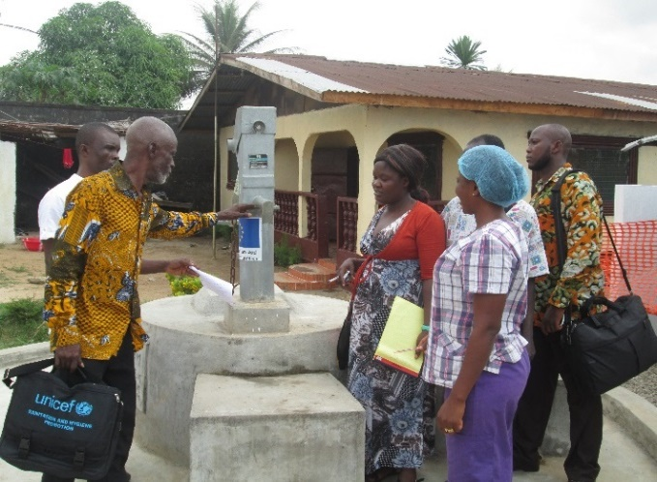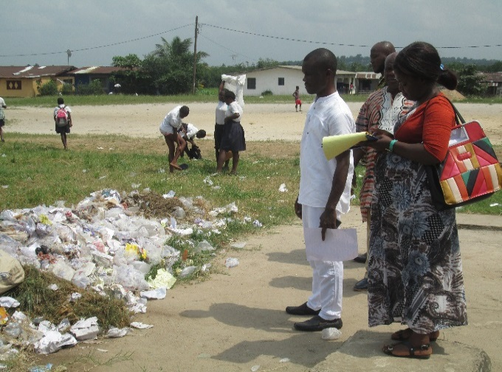
Agent collecting information on a health center facility

6.0 Ebola Response Team Transformations into WASH Committee and Training:

The six Communities Ebola Response Team Transformation into WASH Committee and capacity building training involving Chicken Soup Factory, Swagger Island, Bassa Town or River View, Snow Hill, Palm Hill and LPRC Glass Factory was conducted by the CUPPADL on September 26, 2015

all six communities mentioned for Montserrado communities took place on September 26, 2015 These training were held over the period of one day starting between 9:00am and ran up to 4:00pm. The training was attended by over forty people (45) from diverse background including the community Ebola Response Team members, community youth representative, Elders, Women and some community members.

At the training presentation on the challenges and progress made by each of the teams were done by the heads of the Community Ebola Response Team. They talked about some challenges the Ebola Response Team faced during the implementation of the Ebola Response Awareness meetings and impact made over the past.

At the end of the Ebola Response Team Transformation and capacity building training six communities were given sanitation materials including Wheel barrows, Shovels, Cutlasses and Wipers as a starter in other to enhance their capacity.

Issues raised from presentation on challenges and impact were discussed and decisions such as agreement between the Liberia CSOs WASH Network and the communities were reach and agreed to be documented in a memorandum of understanding to be drafted by the network and signed by both parties. At the training the content of the memorandum between the network and the communities leaderships were discussed and agreed to be included in the MOU. In addition was question such as what will be done in case of new Ebola outbreak were asked and factor in the MOU to be developed.
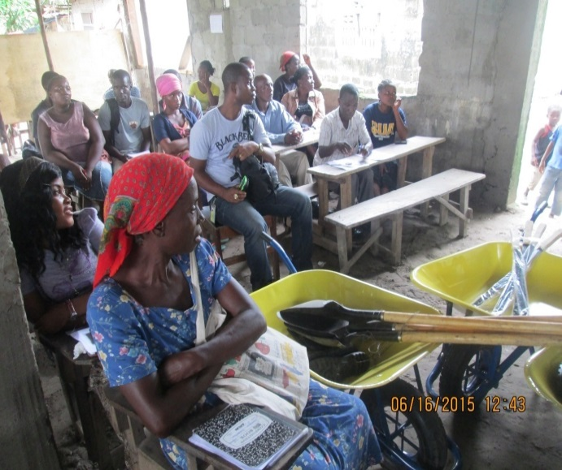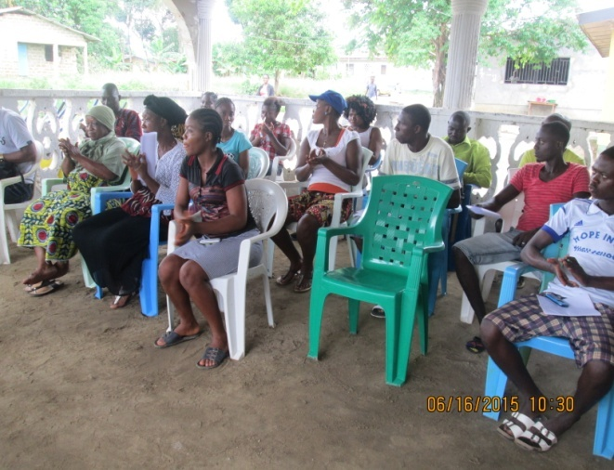
One of Several Communities Materials Donated Participants in one of eight meeting

6.1 Hold Four Counties Investigative Mission:

Investigative missions was held in six counties: Grand Bassa, Margibi, Maryland and Bomi. During each mission, the county legislators, local governments, CUPPADL and media form part of the team which tour several communities and facilities and appraise their WASH condition. The CUPPADL developed comprehensive report narrating the WASH condition in the counties as seen by the team. Following return, the CUPPADL assisted the county legislators in developing an advocacy letter for their respective house’s plenary seeking legislative actions to improve the situation in the counties and the county using the issues found on the mission.

Prior to going on the field tour, mini meetings were held at a designated location of each community and facility to be tour during which briefing on the purpose of the mission were explained to the officer in charge of the facility or community. The CSOs WASH Network news letters and other facts sheets previously developed and updated about the said county were distributed to participants of the meeting. The fact sheet was developed into one page per county.

Output
- 7-10 people attended each mission.
- 15 civil society attended all mission, three at each mission.
- 2 media reporters attend each mission, 10 in total.
- At least 2 legislator attend each mission, at least 10 legislators in total.
- At least 25 people attend each briefing meetings.
- At least 13 briefing meetings held in all four counties and at least 2 in each county.
- One comprehensive report of at least 2-3 pages derived from each meeting, six from all sis meetings and findings published and distributed to stakeholders.
- At least three legislators were supported to submit one letter each to plenary of the both houses of the legislature inform by the reports from the investigation mission.

Legislature inform from the letters and reports took concrete action aim at improving WASH ranging from increasing budget lines, ordering the executive branch of government to establish the commission and or citing executive or private sector WASH service provider to the plenary to explain services provided or not provided issues of concern. County and social development funds in project counties allocate some fund to WASH. Additionally, legislative oversight increase as the result of the information gathered from the various communities and WASH facilities.
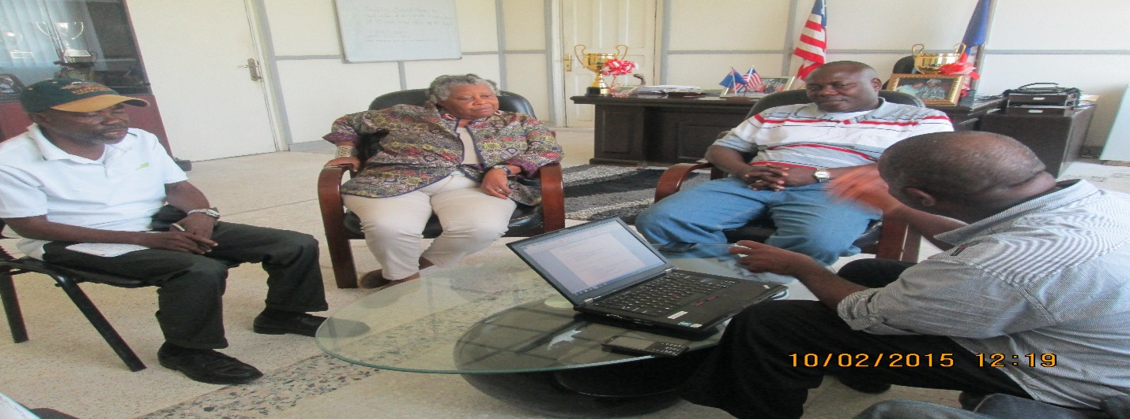
Investigative mission Team chart with Senator Carpie and Bassa Sup

6.2 Evaluation of Liberia SWA statement of commitment
Over the period implementation and researcher was hired to gather data and derived the report documenting commitments made by Liberia under the SWA partnership through the high level meeting on Sanitation and water for all. Additionally, the Consultant was hired to also include in the report the status of the various commitments the country made, which of the commitments realize and the ones not realized the reason for the inability of the government to achieve the specific commitment not realized.

The consultant had mandate to additionally document in the report the challenges responsible for the slow pace of progress in the implementation of the countries commitments as made in the statement of commitment submitted by Liberia to the sanitation and water for all partnership (SWA). Over the period of the consultancy, seven face to face and three groups meetings were hired were held with relevant civil society stakeholders. The meeting with the stakeholders sought to gather the level of the implementation SWA commitments, challenges hindering full implementation of some of the commitments and recommended options for the speedy implementation of those commitments that are not yet been implemented.

The consultant reviewed global and national reports, policies, the SWA commitments and other papers to gather data that will inform questionnaire development, report writing, recommendations and other useful thoughts for decision making from the wider sector. Some of the documents reviewed by the consultant included but not limited to Liberia SWA statement of commitment, Liberia WASH Compact, Water supply and sanitation policy, Integrated Water Resource Management policy, WASH technical guidelines, JMP report among other.

The draft report will be validated in a meeting that will include sector stakeholders such as civil society, government actors, development partners and the media. Prior to said meeting, draft of the report will be circulated via email and hard copy to solicit opinion or respond of each sector group, some will be required to respond on line while others will be required to do their respond in the validation meeting. Following the validation of the report, the Liberia CSOs WASH Network will circulate same officially to the relevant stakeholders including the press, government responsible officials, office of the president of Liberia and WASH Goodwill Ambassador for Africa, civil society and development.

6.3 Hundred Children Walk: On March 24, 2015 At the Capitol Building, over one hundred and thirty (130) Liberian children walked http://www.westafricainfopost.com/index.php/news/368-liberian-children-demand-wash-for-school from the YMCA to the Capitol Building the seat of the country’s National Legislature where they waited several hours in the conference room of the Liberian Senate and the grounds of the capitol due to the engagement of the Senators in their regular plenary session.

After hours of waiting, the Children of Liberia were later taken to the office of Honorable Armah Jallah, President Protemp of the Liberian Senate where they presented a petition statements on behalf of the Liberian children.
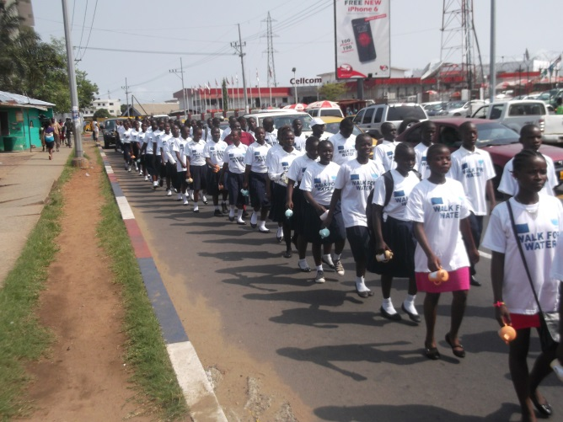

The statement was read by student Lucky Bartee of Charles D. B. King School.

He said:
- He want the legislators through Honorable Armah Jallah office to allocate adequate funds in the National budget for effective and sustained WASH in schools
- He said, legislators should support civil society to ensure WASH in schools
- He demanded the entire legislators to support government action aim at raising up to 60,000,000 US for effective WASH in schools

At the end of Student Bartee presentation on behalf of the Liberian children, Honorable Albert Chea, chairman on Lands Mines and Energy of the Liberian Senate

Said:
- He welcomes the children petition statements and considered it very important
- He said, the problem in Liberia as it relates to water, Sanitation and hygiene is governance
- Honorable Chea said, there is a need to find one agency to in Liberia to address the water problems
- He also said, the water board has been established
- He concluded by saying, as a Senator, he will work with his colleagues to push a bill that will established water commission in Liberia

At the end of Honorable Peter Coleman statements, Honorable Armah Jallah Senate Pro- Tempo of the Liberian Senate made a statement.

He said:
- The petition read and presented by the Liberian children reminds them of their commitments
- The Senate Pro- Temp Said, they will work with their colleagues to improve the WASH situation in Liberia
- He said, they are looking forward in working with the children and state actors in the WASH sector
- Senator Jallah said, the petition statement will be taken before the plenary
- He apologized to the gathered children in his office for coming late due to action in the interest of the Liberian people

On Tuesday March 31, 2015 the Liberian Senate plenary discussed briefly the petition http://www.westafricainfopost.com/images/pdf/WORLD%20WATER%20DAY%20LIBERIAN%20CHILDREN%20PETITION%20STATEMENT%20pdf.pdf presented to the Protempore on behalf of the senate and forwarded the document to the appropriate committees for further deliberation and report back to plenary for appropriate senate action.

6.4 World Toilet Day Mobilization Rally: On the 20th day of November 2015 the Liberia CSOs WASH Network in collaboration with the Citizens United to Promote peace and Democracy in Liberia (CUPPADL) with support from WaterAid Liberia joined the rest of the world in observance of World Toilet Day. The day was set aside in 2001 to focus decision-makers attention to sanitation problems by the United Nations (UN). The 2015 celebration was held in Harper City Maryland County. The celebration started at the hour of 11:30am and lasted up to 5:00pm, brought together eighty five participants including local government officials, Civil Society groups, youth, women, disables, elders and students.

The purpose of the celebration was to raise awareness on the danger of open defecation and demand stakeholders and policy makers to make budgetary allocation in the national budget to improve water, sanitation and hygiene in Maryland county and Liberia at large.

The celebration started with a parade through the principal streets of Harper and climax with a presentation of a petition statement with six (6) counts to stakeholders of Maryland County on the ground of the administrative building.

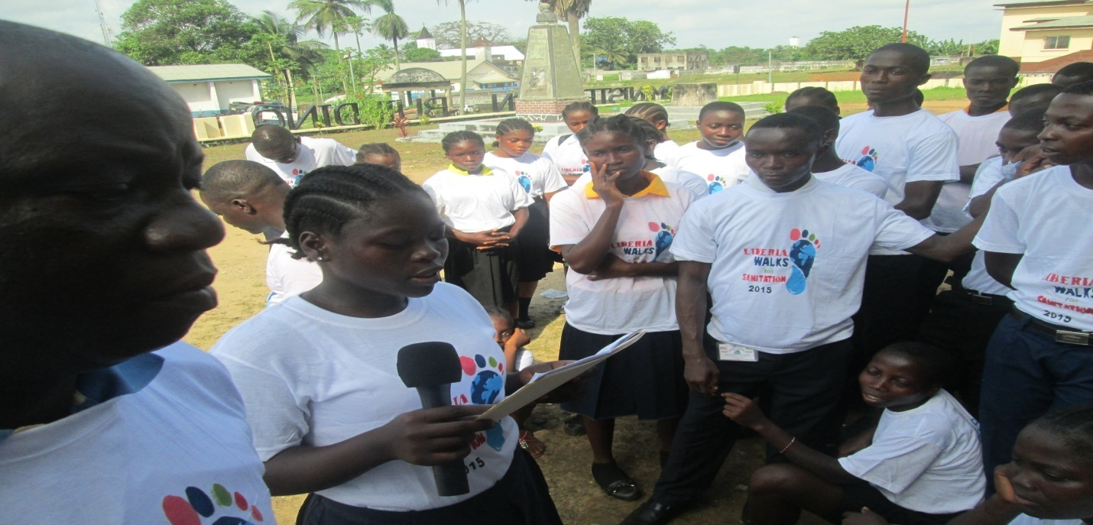
One of the Petitioners Reading Petition to Maryland County Officials

The acting Superintendent of Maryland County Mr. Betsay Kuoh Toe received the petition statement and turned it over to the Development superintendent of Maryland County for response. The Development Superintendent of Maryland County Mr. Nathaniel S. Toe, Jr. responded to the petition statement that was read by student Sharine Wesley J. S. Partt Institute. Said today is a very special day. What make this day so special is because we have garther here to celebrate World Toilet Day along with other countries around the world. He said the issue of open defecation has become an issue in recent time. Sience the sewer system of our county colap, we started to have problems. Today we record in the past, the society was free of open defecation because we have our sewer system functioning. We have water running from one point to another and our drainish system flowing freely because of that Harper was free from open defecation. In area that we done have sewage system, we have public latrine build in those communities. But now we are at another stage, a stage that needs a concrete action as we move toward making the society free from open defecation. He said Liberia have lost her status again. Ebola have resurfaced in our country, so we have to take necessary actions in fighting the deadly Ebola virus.

As we celebrate this day, every one have a responsibility in making show that there should toilet build in their homes. He also told the petitioner that they have been working on the county, district and city level to ensure that everyone who have decide to build a house should understand that he/she have a responsibility to build a toilet in their homes. And that is a policy that has been made for city level and we need to work with those agencies that have the responsibilities to enforce the implement that particular policy.
6.5 Media Campaign
During the year 2015 under reviewed the CUPPADL held several media actions aim at informing the public, government officials and development partners about project economic, social and political benefits to the beneficiaries. The desire behind this was to generate the public support to the organization and influence government and its official’s action at meeting project goals and objectives.

Over the period the CUPPADL activities implementation several reporters were deployed to each of the activities implemented due to which several National Radio, Television and News Papers published in their news and public affairs programs accepts of those activities; the CUPPADL additionally sent a media specialist to the dialogues in the selected counties where dialogue took place to gather information to inform the development of the quarter newsletters.

Also as part of creating inform public about the projects activities and their outcomes and to raise the profile of the project activities, the media network deployed several on the ground local radio reporters to ensure the news and public affairs programs of the local stations publish the issues that emerged at each activity. Several radio and television talk shows programs were held at designated times in all the project counties. Two persons, one from CUPPADL and local government appeared and discussed water, sanitation and hygiene.

The audience had the opportunity to phone-in during the radio and television talk show their opinion on the topics that were under discussion, talk show host was given brief of their opening presentation of the shows to ensure the discussions are program focus and done in a manner that enhances the attainment of project objectives related to media activities.

7.0 International Travels
Over the period of 2015 under review, several international travels were made by senior staffers of the Citizens United to Promote Peace & Democracy in Liberia (CUPPADL) amongst which included but not limited to the following:

- The National Executive Director of CUPPADL Participated and serve as member Liberia join delegation of Government and Civil Society on a National Image Building mission to South Africa. To meet and encourage donors, governments and private sector professionals to relax restriction on travel and operations to Liberia following the outbreak of the Ebola Virus. April 2015.
- He also participated in the Africa Water, Sanitation and Hygiene Civil Society Network Advocacy for WASH SDGs planning Training Workshop in Narobi, Kenya held from November 16—20, 2015.
- Additionally, he participated and serve on the Liberian Government Delegation representing civil society in the Global Call to Action Submit 2015: “Ending preventable maternal and child death” from August 27-28, 2015 in Delhi, India. The delegation was comprising the Minister of Health, Chief Medical Officer of Liberia, Maternal Health Ambassador and the National Executive Director of CUPPADL

8.0 Summary of Financial Report

Over the 12 months (January – December) period of the operations of the CUPPADL in 2015, the organization mobilized funding in the amount of United States dollars One Hundred and Thirty Nine Thousands Three Hundred and Forty Four (US$152,344.00). This amount was mobilized through proposals requesting support for specific programs as mentioned in the narrative report. In some cases, CUPPADL fronted for networks and managed finances, activities, programs and actions for the groups and in addition CUPPADL herself had some of the finances, activities, program and actions allotted to her separately for her exclusive implementation.

Over the year, four international organizations supported separate projects and programs and operational cost of the organization as you will see below:

Revenue

Donor | Project | Project Duration | Amount | Project Year
WaterAid-Liberia  and Sierra Leone | WASH Policy and Service Access Advocacy | 1 year | 29,000.00 | 2015
Oxfam Direct | WASH Policy, Service Access, rights and citizens participation Advocacy and awareness | 1 year | 14,836.00 | 2015
Liberia WASH Consortium - Oxfam | WASH Policy, Service Access, rights, Advocacy and budget tracking | 1 year | 26,120.00 | 2015
National Democratic Institute (NDI) | Building Citizens Center Political Engagement with Legislators and Cabinet Officials | 1 year | 36,866.00 | 2015
WaterAid | Global Dates Campaigning | 1 year | 9,155.00 | 2015
Save the Children International | Maternal, sexual, reproductive, newborn and child health policy, post MDGs engagement and service access advocacy | 1 year | 23,209.00 | 2015
Ministry of Finance and Development Planning Non State Actors Small Grant | Public Finance Management Reform Advocacy. Budget Tracking, analysis, engagement into national budget processes and transparency advocacy | 1 year | 13,000.00 | 2015
Grand Total |  |  | 152,344.00

9.0 Project Challenges
Challenges encountered over the period of the project month are as follow:

- Putting the communities’ leadership in the front of meetings planning and implementation to enhance ownership especially considering their capacity gap in programming skills slow the planning and implementation of the meetings. In an effort to ensure that this approach work, we blended some of the meetings planning and implementation with coaching sessions.
- Getting organizational members to submit standard reports in line with required standard was becoming a problem due weak staff responsible for organization of meetings for the various members’ capacity and due to limited material and logistical capacity of those lead organizations. To address this challenge, we put some of CUPPADL staff for reporting purpose and some materials purchased for the project at their disposal.
- Getting local county officials, legislators of the counties and community leaders attend the dialogues and meetings were a challenged. To mitigate against turn-up of these important elements, we agreed the new dates of meetings and dialogues base on the availability of local county officials and community leaders. During dialogues where county legislators said they were not able to attend, we had agreement with them to send their on the ground office staff but with strong mandate with the understanding that we present policy papers to them subsequently in Monrovia at their Capitol Building Offices.
- Putting the member organizations leadership in the front of action planning and implementation to enhance ownership especially considering their capacity gap in programming skills slow the planning and implementation of the meetings. In an effort to ensure that this approach work, we blended some of the events planning and implementation with coaching sessions. We additionally developed tools that guided their action and they were require to do regular follow-up to well informed members of the network for coaching
- Getting citizens to conduct themselves in an orderly manner took much of our time as few staff who should have been assigned to project direct activity had to be assigned to ensuring the monitoring of conduct of participants of sit-in action.
- Limited resources hinder the implementation of several follow-up actions that were derived from action of project activities such as the health centers assessment and the sit-in action

10.0 Project Results
There are some immediate results of the activities while many of the results as outlined in the project design will be realized over a long term period before they are visible.

Results of the project specific activities are but not limited to the following:

Immediate Result
- The president of Liberia convened in June the Inaugural WASH Board meeting as part of making the Board operational;
- The Liberia WASH Sector 2015 Sector Review draft report released by the 15-20 of July 2015 include in it the president of Liberia January 2015 state of the nation address focus on the six cities water systems restoration;
- Legislators, local counties officials, civil society, community based organizations and the media attention have been drawn to the WASH issues, commitments and they have join follow-up efforts
- Ministry of Education and Health have developed schools opening protocol which has hands washing; WASH in schools as key component for all schools to comply with. The Liberian senate orders the Ministry of Education to postpone reopening of school from February to March citing the poor implementation of over 30 deliverables which also include WASH facilities upgrade, and construction of new ones.
- Senate Protempore place children statement on the senate agenda and read in plenary and sent to committee room
- Government of Liberia through Ministry of Information convened press briefing on WASH civil society position issued on World Water Day celebration
- Minister of public Works commit to include budget line in his ministry budget for WASH
- President in January state of the Nation address pledge to ensure county development funds scale up WASH services at county level
- Through several approached adopted counties legislators were refreshed about the need to focus their attention on water and sanitation. Specially, Senator George Weah in his inaugural address when he was elected as Chairperson of the Montserrado County Legislative Caucus challenged his colleagues to assist their respective districts and communities access save water and sanitary condition.
- The 2015/2016 National Budget allocation to WASH has increase with for the first time wash in schools been factor
- Over 40 community sanitation and Ebola response team members skilled in management of wash facilities
- Capacity of six communities to respond to sanitation issues built and some communities have begun self-cleaning up initiatives
- Several legislators were able to meet face to face with citizens groups, civil society and take their opinion relative to social, political, economic, peace and security challenges. These meetings facilitated participation of the citizens group in national decision making and at the same time inform the oversight and advocacy role and programs of the legislators

11.0 Appendix:
- Financial statements and source documents
- Bank statements 2015
- Template of Letter that organizations submitted to stakeholders in various counties
- presentation of the CSOs WASH network different functions
- Draft Program for different functions
- Fact sheets
- Briefing papers
- Attendance of events
- Petition statements
- Detail WASH facilities assessment report
- Communities Ebola response Work Plans
- WASH and RMNCH Key Ask one pager documents

