Citizens United to Promote Peace & Democracy in Liberia (CUPPADL)
Upstairs Jetty Trading Corporation Building
Airfield Short-Cut Junction
24th Street
Sinkor
Monrovia, Liberia

Annual
Activities Report

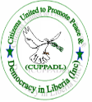

Contact Us
Cell: +231-886-533-015
+231-886-582-878
+231-880-432-605
+231-886-233-254
+231-880-727-429
Email: cuppadlinc@yahoo.com
Period
January to December 2014
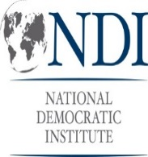
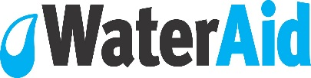
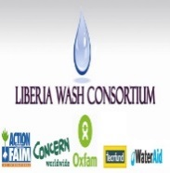
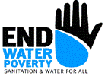
1.0 Introduction
Liberia is slowly recovering from civil war 1989-2003 which witnessed widespread damaged of infrastructures, slow basic social services such as water, sanitation, hygiene, electricity, education, general health etc. additionally, peace, security, justice and human rights situation was badly injured thus leading to the population adopting the posture of taking the law in their hands when they feel aggrieved.

The Poverty Reduction Strategy (PRS), Liberia Demographic Health Survey and other reports estimates inadequate access to safe drinking water, human waste collection and disposal facilities, health care, justice, protection under the law etc.

Since the climaxed of the war in 2003, citizens actions and engagement of public officials to improve service quality and access in other social sectors have gained momentum and service quality and access in these social sectors such as education, road constructions have improved. Citizens engagement of their elected and appointed officials who have the primary responsibility to improve access to basic services, human rights redress mechanisms, policy implementation and formulation was still slow by 2014 as the result of which significant proportion of the population as intimated above was lacking basic services, infrastructures, peace and security etc.

In an effort to mobilize civil society and citizens voices aim at engaging and to hold relevant public officials to take the appropriate action aim at improving access to social services, promote peace and security thereby reducing poverty, the CUPPADL has and continue to partner with national and international organizations to lead advocacy and engagement efforts at the national and sub national levels.

The CUPPADL partnership and advocacy initiatives have been pursued through networking with likeminded organizations and networks including the Liberia CSOs WASH (Water, Sanitation and Hygiene) Network, Maternal and Newborn Health CSOs Advocacy Working Group and the National Budget and Human Rights Forum. These organizations and CUPPADL strongly subscribe to the believe that given the devastating effects of the civil war on Liberia’s human and economic development, a coordinated approach to advocacy has the potential to put forth real effective citizens driven advocacy that could potentially speed the implementation of the government’s Agenda for Transformation, Vision 2030 and the realization of the Millennium Development now Sustainable Development Goals water and sanitation targets.

To this end, the CUPPADL and partners have mobilized funding from several international organizations to implement advocacy and engagement action at addressing the problems mentioned previously. This report will therefore inform its readers, the donors and the people of Liberia and the world about action taken in 2014 by the CUPPADL to accelerate government and other stakeholders’ action to end the social problems, promote peace and sustain security in Liberia. The report content include the problems, activities implemented by the CUPPADL, target set for which activities were implemented, location of activities, timeline and venue, lessons learnt, challenges experienced in project activities implementation and recommended action for the way forward.

2.0 Vision
The vision of the CUPPADL is a Liberia where every person can access basic social services as well the space is provided for direct citizens role in policy formulation, implementation; development planning and public finances are directed for the goods of the population in a manner that promotes individual and general development.

3.0 Mission:
The mission of the CUPPADL is to contribute to the development of Liberia through supporting poor, marginalized, vulnerable groups to access basic social services and built the capacity of civil society and local government to input into policy processes, democracy and peace building initiatives using human rights based and pro-poor approaches.

4.0 Activities Implemented
Activities implemented aim at addressing the problems as mentioned in the introduction and to contribute to the attainment of the Vision, Mission and specific objectives of the CUPPADL included the following:

- Public Finance Management Reform Advocacy and Engagement
- Advocacy for Effective Budget Allocation for RMNCH
- Seven counties stakeholders dialogues or Consultative Meetings on WASH;
- 39 lobby meetings;
- Sit-In-Action at MLME, MOH and MOPW
- Ten Public Schools and Five universities WASH Assessment
- Three Counties Legislative Investigation Mission;
- Support the Liberian Senate Hold Public Hearing on WASH
- Media Campaign

4.1 Public Finance Management Reform Advocacy and Engagement: Under the CUPPADL program focus at transparency, participation and accountability in the management of public finances, the organization secured a small grant with the following Specific objectives:
- To skill civil society and community based organizations in the three project counties in contemporary lobby and media advocacy, budget tracking and monitoring techniques and how to use open budget initiative and freedom of information law in accessing national budget information;
- To create inform public in the three project counties about national budget 2013/2014 allocation on social development projects, projects locations and funds expenditure, and to aware them about national budget formulation and approval processes
- To create the platform for citizens of the three counties to feedback relevant national budget committees in the national legislature and executive officials about national budget social development projects impact, project selection process and challenges faced by projects executers aim at informing decision making related to national budget formulation and approval in the direction of the citizens
- To support civil society and engage them in advocacy for transparency and accountability in national budget 2013/2014 allocation to three counties social projects funds expenditure and project selection

In an effort to achieve the above objectives, over the period of the project one project coordination meeting, two days budget tracking working section, three counties one day focus group discussion, template that Summarized Tracked Projects into each three counties pocket size booklet of allocated projects of 2013/2014 FY was developed and print 300 Summarize Tracked Projects pocket size booklet were held. Additionally, three days skills building training workshop for NSAs in three counties, twelve (12) districts project education and awareness meetings and Engage Co-group in media campaign and advocacy through lobby meetings and media actions were conducted.
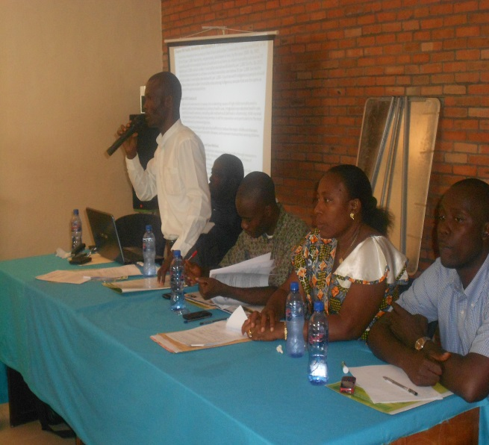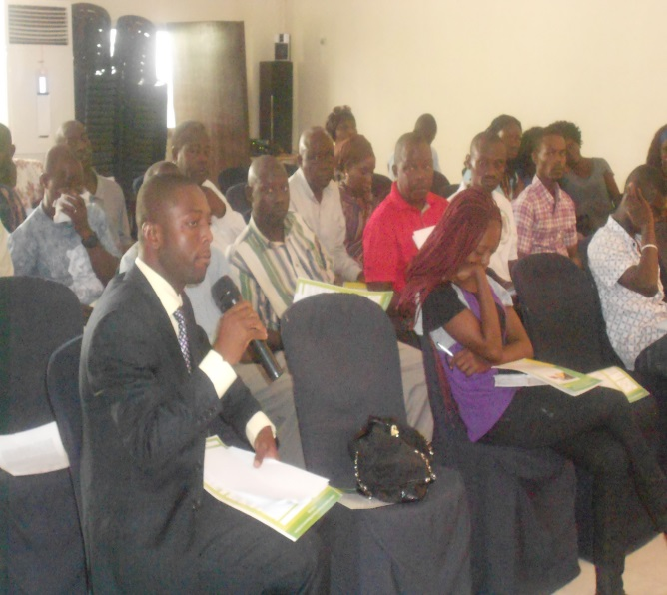
4.2 Hold 3 Days Skills Building Training Workshops and Launch Booklet: The Citizens United to Promote Peace & Democracy in Liberia, Grand Kru Development Initiative (GRANDI) and Amuanu for National Development (AND) held two days skills building training workshop for Non State Actors community based organization in River Gee County at the Red Cross offices in Fish Town. The training facilitated by three trainers brought together over twenty five participants from River Gee and Grand Kru and took place from June 29-30. Additionally, one day training workshop was held in Montserrado for Non State Actors drawn from the county, the training took place at the Market Place in central Monrovia and brought together over twenty (25) participants.
d
The training was focus on skilling participants in various areas including budget analysis and monitoring, advocacy, media engagement, method of use of the three counties social project booklets developed by the project, freedom of information law and open budget initiative. The training was facilitated by three skilled trainers hired by the project to deliver the lessons in the various areas.
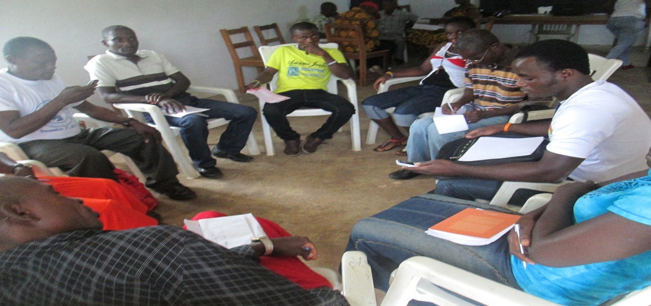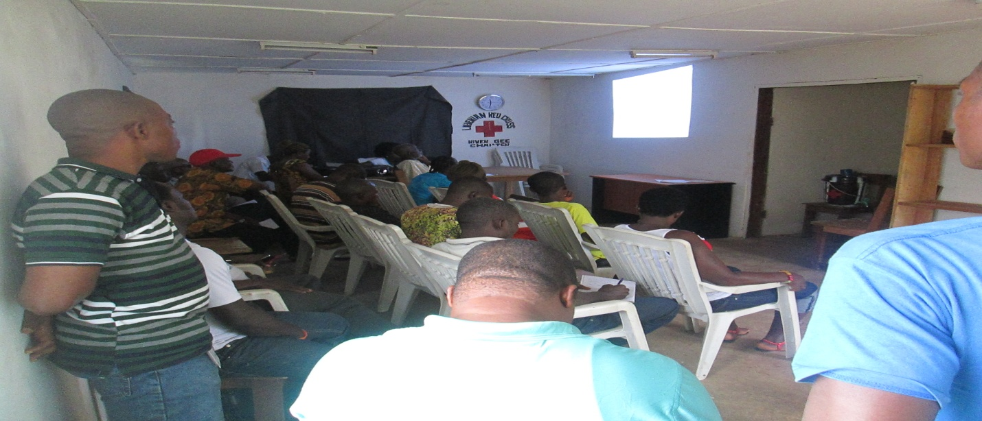
One of Group Working Session and Plenary Discussions in River Gee Skills Building Workshop
Copies of the County and Social Development Funds guide developed by the CUPPADL and her partners as part of the project deliverables were launched separately in the three counties of Montserrado, Grand Kru and River Gee. The launching took place during the inaugural districts meetings in the political capitols of the three counties, over 50 participants attend each of the booklet launch or inaugural meeting including civil society, government, the media and development partners focus on integrity work and PFM sector.
During the launch a member of the CUPPADL presented the content of the booklet in the Montserrado and River Gee launch while a member of Grand Kru Development Initiative (GRANDI) presented the content of the booklet in the Grand Kru launch. Following presentation of the booklet by power point participants had the opportunity to ask presenters questions to which presents had the time to respond. Following the launch participants received copies of the booklet to inform their various work at improving public finance management in Liberia at all levels.

4.3 Health: Advocacy for Effective Budget Allocation for RMNCH: As part of the CUPPADL efforts at ensuring the population access basic social and other rights, it planned, organized and implemented sets of programs towards accelerating the realization of basic social rights and access to social services. In this respect the CUPPADL secured funding support from the World Health Organization through the Save the Children International.

The objectives of the project and means of influencing decision making and policy processes for which the US$20,000.00 was awarded were as follow:
- To increase civil society participation and advocacy in national budget decision making processes and media reportage on RMNCH
- To inform and making civil society participation and advocacy in national budget decision making processes and increase civil society participation and advocacy in national budget processes and media reportage on RMNCH
- To increase civil society participation and advocacy in national budget decision making processes and influence increase public spending and political prioritization of RMNCH and SRHR
- To influence National Legislature to increase national budget appropriation for RMNCR and SRSH
- To deepen population understanding and mobilize their participation in national budget advocacy, preparation and approval processes around RMNCH and SRSH issues.
Activities earmarked to contribute towards the realization of the project objectives as articulates above include skills building training for media and civil society, development of issues paper elaborating issues needing attention in the RMNCH sub sector of the Ministry of Health services prior to the submission of the Ministries estimate to Ministry of Finance, mobilization of CSOs working on budget and human rights issues to attend advocacy meeting with Ministry of Health in order to influence RMNCH Budget estimates for 2014/2015, mobilization of CSOs to participate in the budget formulation/hearing presentation meetings at the Ministry of Finance which last for two weeks, analysis of RMNCH proposed allocation in draft budget contained in overall health budget, three days of preparatory meeting for the development of policy brief targeting legislators, for the influencing of increment in RMNCH appropriation in the overall health budget, publication and media engagement on policy brief prior to presentation to the ways, means and health Committees of the National Legislators, Follow up Lobby meetings & media Advocacy with Legislators and Hold town hall meetings in 5 counties targeting persons of reproductive ages.
Output
- Development and presentation to the Ministry of Finance and National Legislature National Budget teams of Issue Paper on Maternal, sexual, reproductive, newborn health
- Development of and presentation to the ways, means and finance committee of the National Legislature briefing paper that analyze allocation to RMNCH
- Development and presentation to media and civil society lessons on RMNCH reportage and advocacy
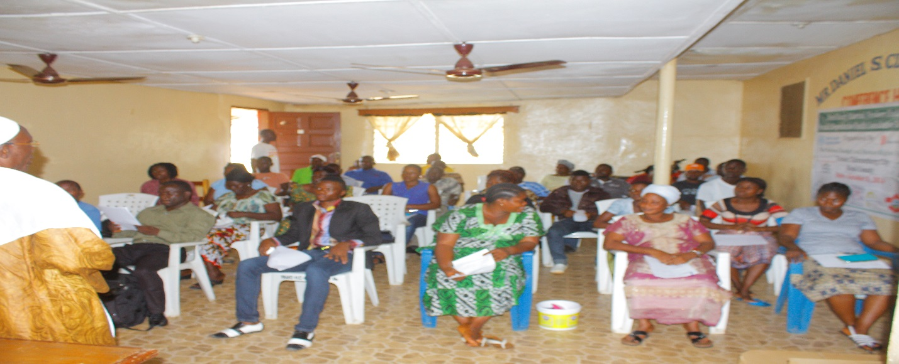

5.0 WASH Policy, Service Access, Rights and Legislative Engagement Advocacy:

As part of the CUPPADL vision to engage stakeholders at influencing access, rights to WASH, policy formulation and implementation coupe with engaging legislators to improve oversight in the sector wide drive toward improving access and quality. The CUPPADL as an institution, in collaboration and partnership with several other organizations implemented the below activities:

5.1 Brainstorming Session Montserrado County: On December 16, and 17, 2014, a two (2) days Brainstorming session involving four communities in Montserrado County on Ebola Response at the Gardnersville Town Hall. The session brought together thirty (30) participants drawn from the four communities in Montserrado County. Each of the four communities was represented by 5-7 persons. The composition of the communities’ participants included women, civil society organizations, youth and general community leadership.

In addition to the communities participants included government official, the District Representative and the CSOs WASH Network representation. The meeting started from 9:00am and ended 4:00pm each of the two days. At the meeting welcome and overview of the meeting was done by Mr. A. Saydee Monboe Secretary General of the Liberia CSOs WASH Network.
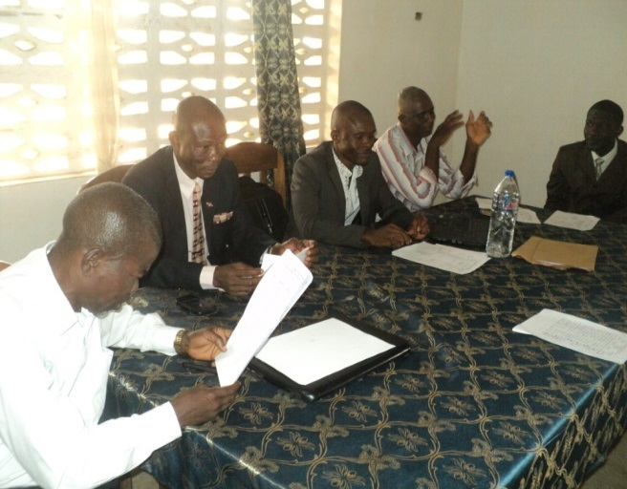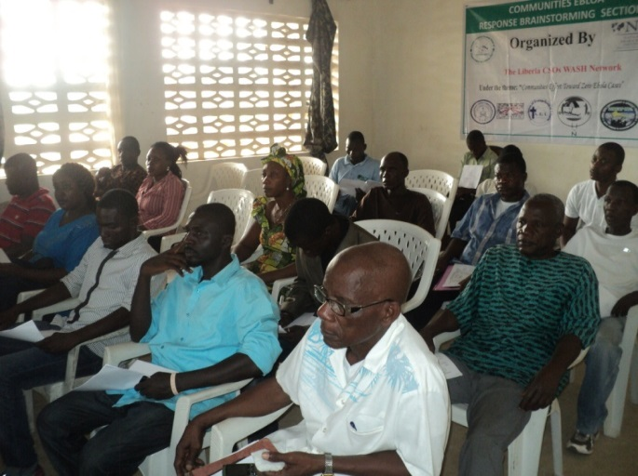
Rep. Anderson, Com. Rep and WASH Net Heads Participants of Brainstorming Session

Communities were cluster into group, during which time each community gather data to inform their community Ebola situation analysis and developed detail community Ebola Response Plan for their individual communities. Each plan identified resources available, resources needed from partners, sources of resources, time line for the implementation of each activity, activity to be implemented for the attainment of objective etc.

Additionally, each community Ebola response situation analysis answered such questions as method of Ebola spread in the community? Strategy/activities to prevent and stop the spread of Ebola in the community; active structure and existing action taking place or have happened in the communities; activities done in the communities to stop the spread of the Ebola; areas of support needed; method of gender integration; and legislative engagement.

5.2 Budget Tracking, Monitoring and Advocacy: On April 10, 2014 as part of the Irish Aid supported activities the Liberia CSOs WASH Network through its Member Citizens United to Promote Peace & Democracy in Liberia held one day working section with WASH and Budget Advocacy Focus civil society organizations which included the Citizens United to Promote Peace & Democracy in Liberia (CUPPADL), Women NGO Secretariats of Liberia (WONGOSOL), Liberia NGO Network (LINNK), Concerned Christian Community (CCC), WASH Media Reporters & Editors Network of Liberia, and Association of Evangelicals of Liberia (AEL). The working section took place in the conference Room of the Citizens United to Promote Peace & Democracy in Liberia from 9:00am to 5:00pm. The purpose of the working section was for civil society to review national and international policies and the National Budget 2013/2014 to inform the development of a briefing paper on the country WASH sector performance covering policy commitments, public financing and accompany achievement and gap in implementation. The essence is to use the paper to inform legislative and cabinet officials lobby and as well to inform civil society and other interest groups advocacy.
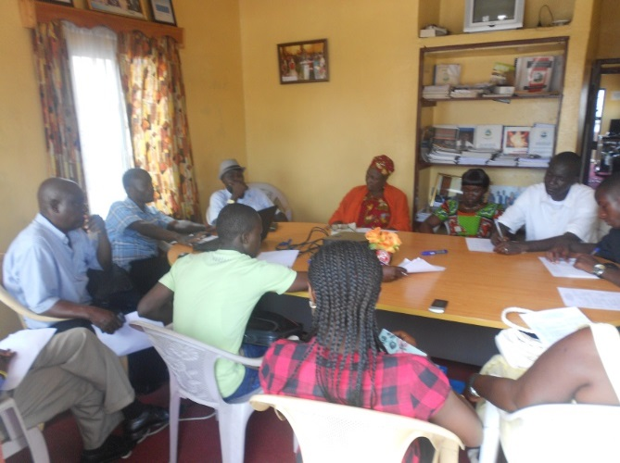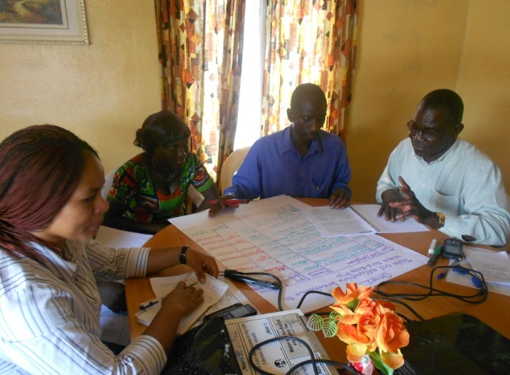
Participants Discussing One of Groups Discussions

At the working section, overview of the WASH sector of Liberia was made; copies of printed policies and the national Budget were made available to the disposal of the participants. Participants were divided into two groups with one group reviewing National Budget and other desk studies reports on the WASH sector to document level of public financing and implementation of policy commitments while the second group had the mandate to document problems and various commitments made by the government of Liberia to address the identified problems.

Following briefing, overview and detailed discussion of the participants of the working section were constituted into two working groups. The two groups discussed over the period of one hour and report back on the following topics:

The outcome of the session is a briefing paper that document the policy commitment, legal basis and resource allocation in the National Budget and other policies on water, sanitation and hygiene.

5.3 Citizens Awareness and Voice out Meeting in Commemoration of World Water Day: Three citizens Voice out and awareness meetings took place on the Capitol By-Pass, West point and Clara Town communities with venue at GW Gibson School campus, on the West Point Sport field and in the Clara Town Hall. Several political leaders, school administrators, civil society and INGOs leaders were in attendance notable among the attendance included the Hon. Thomas Bureh, Commissioner Independent Human Rights, Representative Moses Acarous Gray of District #8 Montserrado and Solomon George of District #7.
The awareness creation and citizen’s voice out meetings were led by the Citizens United to Promote Peace and Democracy in Liberia, Liberia NGOs Network and the Women NGOs Secretariat of Liberia. The three meetings took place at the G W Gibson High school Auditorium on Capital bye-pass, Clara Town Hall on Bushrod Island and the West point football field in Monrovia in March 2014 from 10:30am to 3:00pm.
Civil society organizations leaders, government officials from (ministry of health and social welfare), MCSS-Monrovia Consolidated School System represented by its Superintendent Mr. Adolphus P. Jacobs, G W Gibson principal proper and Vice principal for administration VPA, former Liberia Water and Sewer Corporation Managing Director Hu-Bon Tulay, Honorable Moses Acarus Gray, Representative District #8 Montserrado county, Technical and Management Team of Triad Global Liberia Limited INC, an ultra-filtration unit (water treatment system), the media, students, community members and officials of Rock Spring valley.
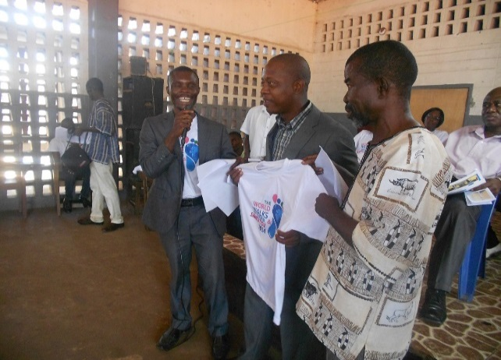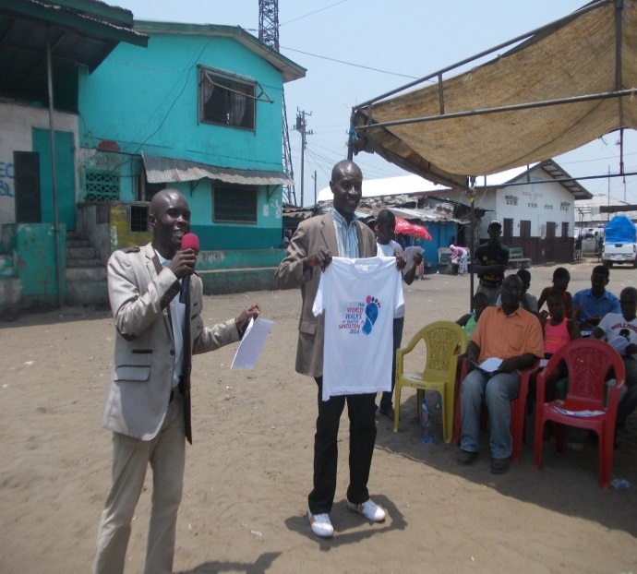
Representative Gray and George Presented with WWD T-shirt and accept to be WASH Champion in the Legislature of Liberia
The key note address at the GW Gibson meeting was delivered by Montserrado County District #8 Representative, Honorable Moses Acarus Gray, the one at Clara Town was delivered by Hon. Thomas Bureh, Commissioner Independent Human Rights while the message for the West Point Football field was delivered by Representative Solomon George.
Selected and well orientated representatives of various marginalized segments of the citizenry were given space to share their experience as the result of lack of access to WASH. These testimonies were aired on the various mass electronic media.
5.4 Community Ebola Awareness Outreach: Over three months of community Ebola awareness outreach was done during the entire project period under the theme “Community Action towards Zero Ebola Cases”. The Montserrado, Margibi and Bomi counties community door to door outreach on Ebola of community’s animators began in all the six communities including Snow Hill, Bassa Town or River View, Chicken Soup Factory, Swagger Island, Dolo Town and Vai Town.
In Snow Hill and Chicken Soup Factory Communities each of the seven (7) animators recruited and trained by the project and two from the Ministry of Health reach out to over one thousand homes. In Swagger Island and River View or Bassa Town over six hundred and fifty (650) were reached out to in the awareness creation exercise. In Vai Town and Dolo Town in Margibi and Bomi over 900 homes were reached out to involving over 9000 inhabitants, seven (7) animators in each of the two communities did the outreach applying skills acquired from the orientation training workshops conducted during the 1st phase of the project activity implementation.

The awareness team were unified and identified with white T-shirts marked with NDI and CUPPADL logos, the theme of the campaign “Communities Effort towards Zero Ebola Cases” at the back of the T-shirt is marked “Community Ebola Response Team”. Additionally, the awareness team members were given a pair of rain booth each; they also carry a batch marked with the name, ID number, NDI and WASH Network Members logos for identification purpose.
Each animator was given a reporting form which they are trained to use to report back to the program staff of project every week end; note pad and pen were given to each of them to gather information while in the field and the form is intended to be filled from the note pad. The various communities team members selected three days in the week for their outreach, some communities reach out every Monday, Wednesdays and Fridays while others were using Tuesday, Thursday and Saturday. Team members went in the field each day from 8:00 am to 5:00 pm following muster during which method of outreach and approach of the population were explained to team members.
The daily routine was that the team members gather in the morning for briefing on the method and approach they intend to use in their outreach; the team members proceed together from door to door educating people, posting and distributing flyers.
As the result of the outreached in the six communities by communities Ebola Response teams with support from the Liberia CSOs WASH network the following gains were made in the community Ebola response and challenges were experienced:
Gains Made
- The six communities are among the supportive of the Government of Liberia and development partners efforts at ending the virus
- Communities knew those to contact for ambulance, ambulance team reported to the calls of communities due to the inform manner calls were made. There were several calls for the ambulance teams (save burial and ill patients report to the ETU).
- Unlike in the past, where took several couple hours if not days to get suspected infected person to be taken to hospital, the intervention of the Liberia CSOs WASH Network project have of late influence the accessing of ambulance by communities at most 30 minutes
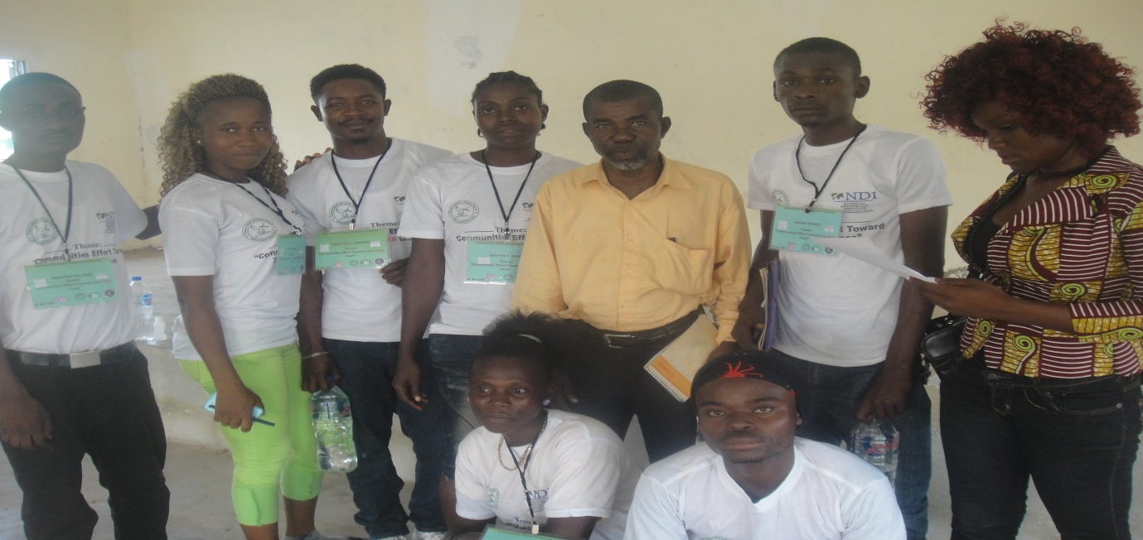
Dolo Town Outreaches
5.5 Stakeholders Dialogue or Consultative Meetings on WASH:
Over the Period of 2015 five (5) counties water, sanitation and hygiene Stakeholders dialogue were held in Margibi, Lofa, Nimba, Montserrado, Grand Bassa, Grand Kru and Bomi. Sixty (60) to seventy (70) stakeholders drawn from women, youths, community leaders, local governments and county legislators were in attendance at each of the dialogues. These meetings created the platform where policy makers from local, legislator and national levels met face to face with citizens groups discussed, reached agreement towards improving access to WASH and governance.

The stakeholder’s dialogues pattern of organization created space for Liberia CSOs WASH network to make presentation on their awareness of the six cities water system, the previous stakeholders meetings in the counties and wash problems while suggesting the way forward to addressing those identified problems. Additionally, the Liberia Water and Sewer Corporation was requested through its county chapters in the two counties to present to the dialogue the status of the restoration of the city water systems outlining challenges, prospects and opportunities of the cities systems completion on time. For their part the local authorities were requested to present their awareness of the status of the cities water system and action taken by them to improve WASH in their counties.

Following these presentations, the participants of the five counties water, sanitation and hygiene stakeholders were split into three groups each where each group discussed identified issues and reached recommended points aim at improving access to water, sanitation and WASH governance. The various groups had the opportunity to presented their findings to plenary after which plenary adopted and mandated the CUPPADL to develop a county WASH policy paper for onward presentation to the legislative caucus, local county authorities, the national government and the press for the required action. Additionally, it inform consolidated policy paper presented to the House of Representatives committees responsible for water, sanitation and hygiene during the public hearing.

5.6 Hold 39 Lobby Meetings with Legislators and Cabinet Officials: During the period under reviewed (2014) thirty nine (39) lobby meetings were held separately with selected legislators, local governments and cabinet officials of government. The objective of the meetings was to influence political actions from individual officials of government and the governmental structural aim at improving water, sanitation and hygiene service quality, access, governance and policy implementation.

Each of the meeting which took place in the offices of the officials met with lasted for at least 1 hour and at most 2 hours. A designated representative of the civil society delegation presented civil society issues to the official of government in oral and written one page document. At each meeting, following the presentation of civil society issues, the official of government had the opportunity to respond to the civil society issues raised.

Cabinet officials of government met with included Jackson Paye, Deputy Minister of Public Works for Rural Development, George Yarngo, Assistant Minister of Public Works for Rural Development and Community Services, etc. Legislators visited included Deputy Speaker of the House of the legislature, Hense Barchue, Senator Joyce Musu Sumo of Montserrado, senator Oscar Cooper of Margibi and Chairman on the Senate Committee on Public Works, Senator John Barllout of Maryland, Senator Sando Johnson of Bomi, Representative Haja F. Sayon of Bomi, Representative Bhofa Chambers of Maryland, Representative Solomon George of Montserrado, Representative Thomas Fallah of Montserrado, Representative Richmond Anderson of Montserrado, Senator Geradine Doe Sheriff of Montserrado, Representative Emmanuel Nuquay of Margibi, representative Garison Yealou of Nimba, Clarence Massaquoi of Lofa, etc.
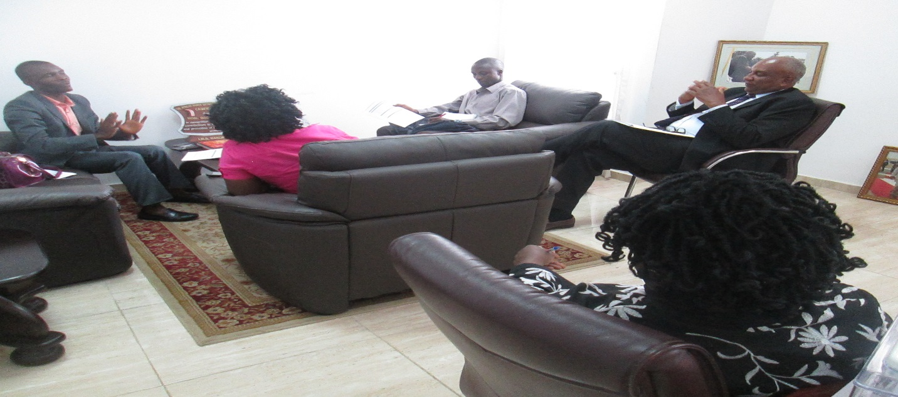
Senator Oscar Cooper of Margibi and CUPPADL Delegation Charting

Issues Discussed with Legislators, Local Governments and Cabinet Officials Separate
During separate meetings with senators, member of the House of Representatives and executive officials civil society campaigners for right and access to water sanitation and hygiene discussed the 2014 Liberian Senate committee on Public Works public hearings on WASH draft report which have since been in committee room. The civil society campaigners members of the Liberia CSOs WASH Network appeal to the conscious of the lobbied senators and representatives to use their influence with the committee to ensure the committee report is submitted to the senate plenary for discussion and action.

A fact sheet that contains access level of various counties relative to water sanitation and hygiene content was disseminated to the senator and representatives met with the CUPPADL team. The fact sheet information included water sanitation access levels in schools and communities of the various counties and the country in general. The purpose of disseminating these data to legislators was to influence political interest in WASH and inform their legislative oversight on the executive agencies responsible for WASH governance, service provision, and service access and service quality.

Additionally, the WASH campaigners lobby meetings with legislators inform them about the president of Liberia and WASH Goodwill Ambassador for Africa mentioned of WASH in her 2015 state of the Nation address highlighting her mentioned of 67% of the country population having access to WASH and 33% without access, 15% of population having access to improve sanitation while 85% without access and 5% of the population practice safe hygiene while 95% does not. The campaigners used the occasion to inform or bring to the attention of legislators the president mentioned of six cities water systems restoration commencement by January 2015 after these systems according to the president restoration was halted due to the outbreak of the EVD. The campaigners lobby the legislators to regularly cite the Liberia Water and Sewer Corporation to update those (legislators) on the status of these systems restoration as mentioned by the president.

The campaigners also lobby legislators to demand integration of various sector issues including WASH in the post 2015 development agenda of Liberia and the globe while performing their oversight responsibility on the executive.

5.7 Sit-In-Action at MOH, MFDP and MOPW: Over the period of the project activities implementation as part of agreement enter into with donors three Sit-In Action or Rally for water and sanitation access was held on the grounds of three Ministries of the Government of Liberia including Ministry of Public Works, Ministry of Health, and Ministry of Lands Mines and Energy.

The purpose of the sit in action was to demand public official to take concrete action on commitment made by them on WASH. The Objective was to put people at the center of advocacy with the aim to influence the operationalization of the WASH Board and establishment of Water Sanitation and Hygiene Commission as the surest way of improving governance in the WASH Sector.

In fulfillment of civil society civic responsibility the three Sit – In – Actions were held at three different ministries named supra. During each of the three sit in action overview of the meeting was performed, petition statement were presented to the ministers in the midst of a crowd of 90-100 identified with flyers and wearing t-shirts marked pro water and sanitation messages.

Each of the Sit-In-Action was attended by over fifty (50) people including women, youth, community leaders, members of the CUPPADL and the media.

At the start of each of the action on the arrival of the designated government representative an overview statement was presented on behalf of the CUPPADL by one of the resident of the various communities that attended.

During the overview the civil society campaigners designated representatives focus their comment on the following:

- The problems for which the action was convened
- What action government and the designated agent must take to address the situation
- The potential benefit expected from the government action

At each Sit-In Action petitioner had the opportunities to display flyers with different messages in support of water, sanitation and hygiene. Petition also chanted slogan and sang songs in support to WASH with the desire to draw WASH stakeholders attention. At the event as was the case of others, petition statement was delivered by petitioner to the Ministry leadership.
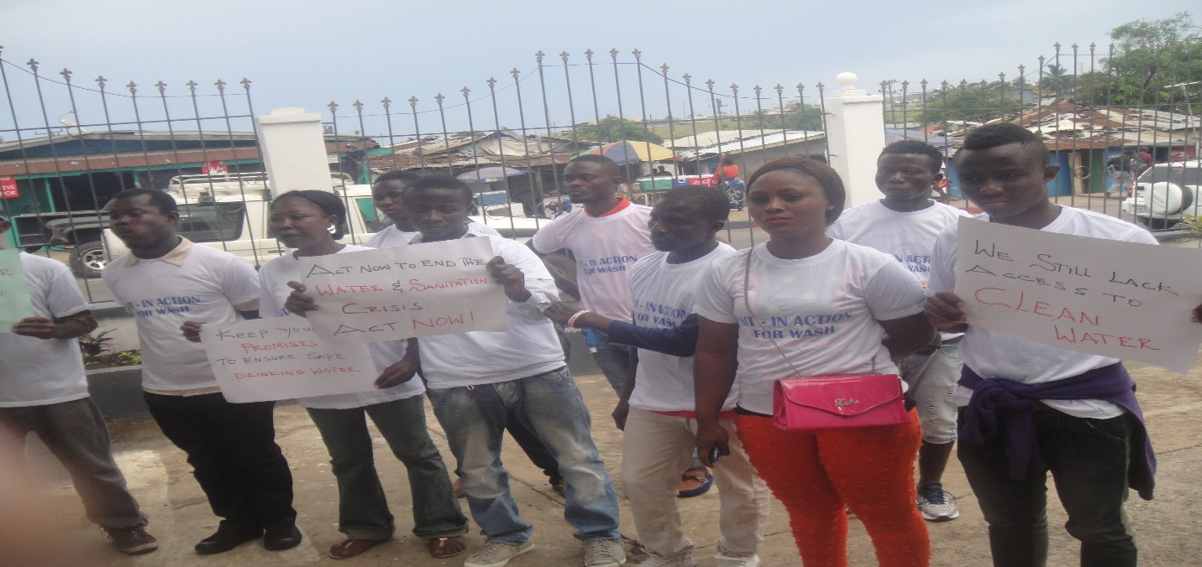
Campaigners posted at the Ministry of Lands Mines and Energy

5.8 Ten MCSS Schools and Five Universities WASH Assessment: Over the period of 2014 ten (10) Public Schools and five (5) Universities in Monrovia water, sanitation and hygiene conditions were assessed. Prior to the assessment, one day orientation training was held with WASH CSOs assessment agents to enhance their capacity to conduct WASH Assessment in Public school Facilities. The training took hands on approach 80% practical and 20% theory.

The data agents who received training and was deployed in the field to collect data were drawn from four of the six WASH network member organization including the Association of Evangelicals of Liberia, Concern Christian Community (CCC), Women NGOs Secretariat of Network, Citizens United to Promote Peace and Democracy in Liberia (CUPPADL). The total number of eight (8) people, two each from the four organizations of the WASH Network member’s.

Data collection agents who were deployed in the field were given various tools to facilitate their data collection including questioners, recommendation letter to be presented to the management of the school, camera, note pad and other essential materials. Prior to the data agents’ deployment in the field, communication seeking the cooperation of the school administration was served each school.

The Ten School facilities assessed were as follow:
- G W Gibson High School
- Gray D. Allison School
- New Port High School
- William Gabriel Kpolleh High School
- Botswan High School
- Slip Way Elementary School
- D-Twe Memorial High School
- Marvi Sonii Public School

The Five Universities Assessed are as follow:
- AME Zion University
- AME University
- Stella Maris Polytechnic
- United Methodist University
- Smythe Institute of Management

Following data gathering selected few of the data collection agents team-up with the lead researcher to summarize the data from each form into a report. Several working session and validation meetings were arranged with the general data collection agents, sector stakeholders and school authorities to facilitate their reaction to the aspect of the report related to them in an effort to ensure the issues raised by the report are nothing but the truth.

5.9 Hold Three Counties Investigative Mission: Investigative missions was held in three counties: Montserrado, Margibi and Nimba. During each mission, the county legislators, local governments, CUPPADL and media form part of the team which tour several communities and facilities and appraise their WASH condition. The CUPPADL developed comprehensive report narrating the WASH condition in the counties as seen by the team.

Prior to going on the field tour, mini meetings were held at a designated location of each community and facility to be tour during which briefing on the purpose of the mission were made to the officer in charge of the facility or community. The key ask, newsletters and other facts sheets previously developed and updated about the said county were distributed to participants of the meeting.

The fact sheet was developed into one page per county.

Output
- 7-10 people attended each mission.
- 9 civil society attended all mission, three at each mission.
- 2 media reporters attend each mission, 6 in total.
- At least 2 legislators attend each mission, at least 10 legislators in total.
- At least 25 people attend each briefing meetings.
- At least 6 briefing meetings held in all three counties and at least 2 in each county.
- One comprehensive report of at least 2-3 pages derived from each meeting, six from all three meetings and findings published and distributed to stakeholders.

Legislature acquired firsthand information about the situation on the ground relative to water, sanitation and hygiene service, facility in the three counties. Through these information legislators, local government planning and civil society and the media advocacy were informed.

6.0 Support Senate Public Hearing on WASH: The Liberia Civil Society Water, Sanitation and Hygiene (WASH) Network hosted and coordinated by the Citizens United to Promote Peace & Democracy in Liberia (CUPPADL) with funding and technical support from the Swedish Embassy through the National Democracy Institute (NDI) for International Affairs co-hosted alone with the NDI an investigation mission focus on establishing Water and Sanitation situation in Montserrado County.

One of Montserrado County two Senators, Musu Freeman along with West Point and Clara Town Townships Commissioners were taken on a guided tour of several water, toilets and the White Plain Water Treatment facilities in Montserrado County. Five days after the investigation mission, CUPPADL supported Senator Sumo to present a letter to the Liberian Senate Plenary seeking investigation that will lead to concrete Senate action to improved conditions established during the investigation.

Based on the letter presented by the Senator, and the robust civil society engagement through lobby advocacy, with funding support from the Swedish Embassy through the National Democracy Institute for International Affairs, the Senate arranged public hearings and set same for May 5, 2014. The line Water, Sanitation public ministries and agencies along with five civil society groups were invited to share their expert views to inform the Senate Plenary action.
The Liberian Senate committees on public corporations and Public Works, conducted a one day Investigative Hearing to examine the Water Sanitation, and Hygiene (WASH) conditions and issues in Montserrado and the country and recommend appropriate Legislative action(s) to improve the situation of WASH. The meeting was live broadcast with support from the CSOs WASH Network with funding support from Water Aid-Liberia.

The hearing was attended on invitation by several segments of civil society including the disables, students, women & children and International NGOs partners. All of the invited civil society organizations presented their expert knowledge on issues and challenges within the WASH sector, the Liberia CSOs WASH Network and CUPPADL supported the national civil society stakeholders in the development and presentation of their expert opinions through the holding of a preparatory meeting and facilitation of rural civil society participation.
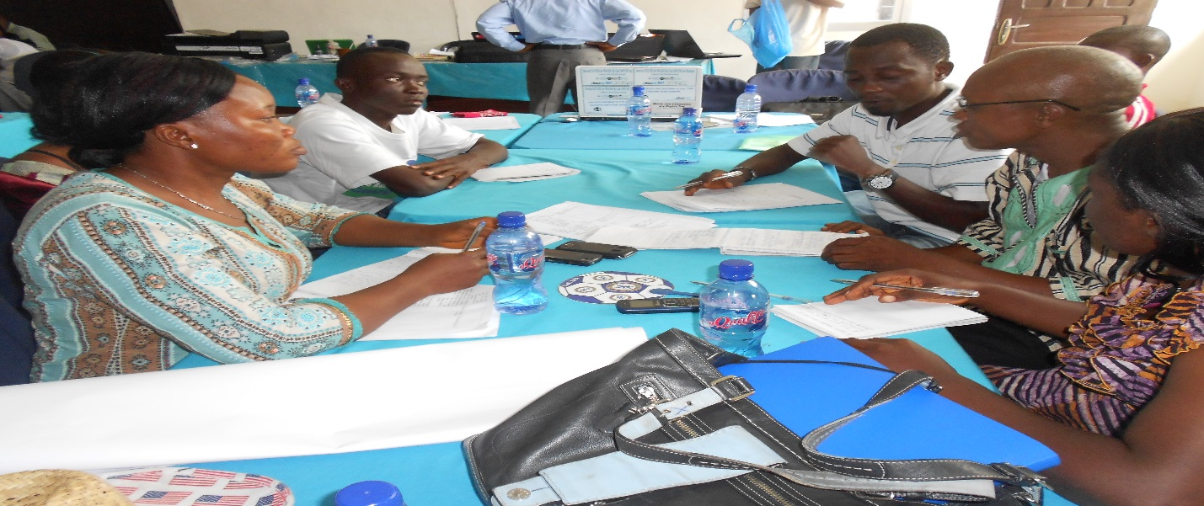
Public Hearing CSOs Prep Meeting Participants

6.1 Media Campaign
During the year 2014 under reviewed the CUPPADL held several media actions aim at informing the public, government officials and development partners about project economic, social and political benefits to the beneficiaries. The desire behind this was to generate the public support to the organization and influence government and its official’s action at meeting project goals and objectives.

Over the period the CUPPADL activities implementation several reporters were deployed to each of the activities implemented due to which several National Radio, Television and News Papers published in their news and public affairs programs accepts of those activities; the CUPPADL additionally sent a media specialist to the dialogues in the selected counties where dialogue took place to gather information to inform the development of the quarter newsletters.

Also as part of creating inform public about the projects activities and their outcomes and to raise the profile of the project activities, the media network deployed several on the ground local radio reporters to ensure the news and public affairs programs of the local stations publish the issues that emerged at each activity. Several radio and television talk shows programs were held at designated times in all the project counties. Two persons, one from CUPPADL and local government appeared and discussed water, sanitation and hygiene.

The audience had the opportunity to phone-in during the radio and television talk show their opinion on the topics that were under discussion, talk show host was given brief of their opening presentation of the shows to ensure the discussions are program focus and done in a manner that enhances the attainment of project objectives related to media activities.

7.0 International Travels
Over the period of 2014 under review, several international travels were made by senior staffers of the Citizens United to Promote Peace & Democracy in Liberia (CUPPADL) amongst which included but not limited to the following:

- The National Executive Director of CUPPADL representing Liberia civil society attended as Member of Liberia Delegation Representing the Africa Water Week, May 26-31, held in Dakar, Senegal
- In April the National Executive Director of CUPPADL attended and presented civil society statement to the Africa Human Rights Council in Gambia, Banjul at the Sene-Gambia Hotel. The event marked the gathering of AU Human Rights Commissioners, member governments, civil society and the media
- In March of the same year prior to the 1st Ebola Outbreak in Liberia the National Executive Director of CUPPADL attended continental civil society conference in Senegal, Dakar on Universal Access to Health Coverage

8.0 Summary of Financial Report

Over the 12 months (January – December) period of the operations of the CUPPADL in 2014, the organization mobilized funding in the amount of United States dollars One Hundred and Thirty Six Thousands Eight Hundred and Forty Five (US$136,845.00). This amount was mobilized through proposals requesting support for specific programs as mentioned in the narrative report. In some cases, CUPPADL fronted for networks and managed finances, activities, programs and actions for the groups and in addition CUPPADL herself had some of the finances, activities, program and actions allotted to her separately for her exclusive implementation.

Over the year, over five international organizations supported separate projects and programs and operational cost of the organization as you will see below:

Revenue
Donor | Project | Project Duration | Amount | Project Year
WaterAid-Liberia  and Sierra Leone | WASH Policy and Service Access Advocacy | 1 year | 35,000.00 | 2014
Save the Children International | Maternal, Sexual, Reproductive, newborn health policy, budget tracking and service access and rights advocacy and awareness creation | 1 year | 35,130.00 | 2014
Plan International | Day of the African Child celebration, engagement of children in WASH advocacy | March to April | 1,230.00 | 2014
National Democratic Institute (NDI) | Building Citizens Center Political Engagement with Legislators and Cabinet Officials | 1 year | 30,000.00 | 2014
WaterAid and others | Global Dates Campaigning | March to April | 14,155.00 | 2014
Liberia WASH Consortium | WASH Policy, service access, rights advocacy and awareness creation | 1 year | 21,330.00 | 2014
Grand Total |  |  | US$136,845.00

9.0 Project Challenges
Challenges encountered over the period of the project month are as follow:
- Travel to counties in the south east was restricted as measure to stop the spread of the virus to those counties. Travelers to these counties had to sleep nights to the borders before been allow into these counties. As a means of ensuring we meet up with project objective we had to follow such restriction order something which causes us more transportation and lodging expenditure that expected
- Getting to the project counties was one of the major challenge because of bad road the transportation to these counties increase little over previous days fees.
- Public congested gathering were stop by the government as such we had to hire bigger hall than expected
- Some of the anticipated stakeholders were hesitant attending the meetings due to fear for the contraction of the virus. As a means of addressing this fear we assure that we were using hall larger more than four times the number of people to attend
- There were delay in disbursement of funds for the implementation of activities

10.0 Project Results
There are some immediate results of the activities while many of the results as outlined in the project design will be realized over a long term period before they are visible.

Results of the various project implemented specific activities are but not limited to the following:

Immediate Result
- The president of Liberia established WASH Board, name members to the board;
- Over 150 people from three counties aware of the project, its anticipated social and economic impact on their and community development
- Over 150 people from the three counties commit to support implementation agencies in the realization of project objectives
- The three project and other counties social and county development funds allocated in the national budget well documented and will assist inform advocacy and development planning at the county and national level
- Increase of the population of Liberia access to water to 67% by January 2015 according to the president of Liberia state of the nation address
- National and local public officials including the President, Speaker of the House of Representatives and President Protemp of the Liberia senate speak on, take measures and challenge their subjects on WASH
- Civil society from the three counties were able to use the Open Budget Initiative and gather information about their counties social projects in the National Budget
- More civil society and citizens group engage in advocacy for transparency and accountability in national budget allocation to three counties social projects funds expenditure and project selection
- Civil society in three project counties inform about national budget 2013/2014 allocation on social development projects, projects locations and funds expenditure
- Over 100 civil society, community based and faith organizations leaders in three counties acquired skills in contemporary lobby and media advocacy, budget tracking and monitoring techniques and how to use open budget initiative and freedom of information law in accessing national budget information, human rights based approach to budgeting, development planning
- Over 100 civil society, community based and faith organizations leaders in three counties aware of the national budget processes and use knowledge acquired in national budget debate
- Over 100 civil society, community based and faith organizations leaders in three counties aware of their CDF, SDF funds expenditure procedure and project identification method and demand accountability and transparency
- Over 100 civil society, community based and faith organizations leaders in three counties aware of their CDF, SDF and other social projects funds allocation in national budget for their counties
- Civil society forum and members had the opportunity to attend the National Budget Hearing focus on health usually held by the Ministry of Finance before the finalization of the daft National Budget. The group had the opportunity to engage relevant officials even though were permitted to comment but was rejected by one of the Deputy Minister of Finance
- Liberia senate for the first time hold public hearing on water, sanitation and hygiene solicit civil society especially in rural communities opinion and derived report that mandate the executive to take stronger measures at improving governance and service access
- Increase in media coverage and citizens demands to political leaders for improve access to water, sanitation and hygiene
- Ten public schools in Monrovia and five universities commenced improvement in their water, sanitation and hygiene facilities at those institutions. Other institutions of learning convicted by such action and for fear of been the network next target undertake measure to improve their facilities

11.0 Appendix:
- Financial statements and source documents
- Bank statements 2014
- Template of Letter that organizations submitted to stakeholders in various counties
- presentation of the CSOs WASH network different functions
- Draft Program for different functions
- Fact sheets
- Issues and briefing papers
- Attendance of events
- Petition statements
- Detail WASH facilities assessment reports
- Counties WASH resolutions
- WASH and RMNCH Key Ask one pager documents
- CDF and SDF Guide Booklet
- Training presentations

