Pectoral view of participants at the one (1) Day Petition Action on SRHR/RMNCH

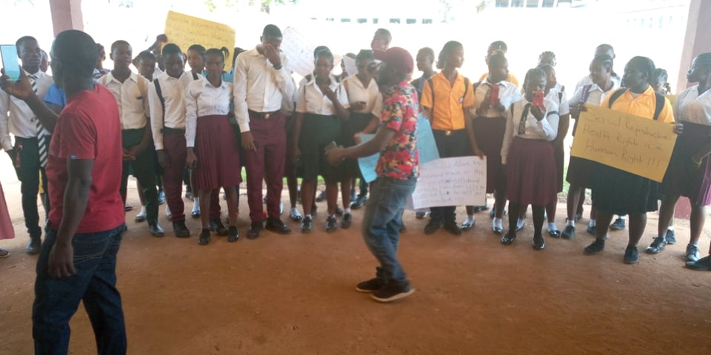
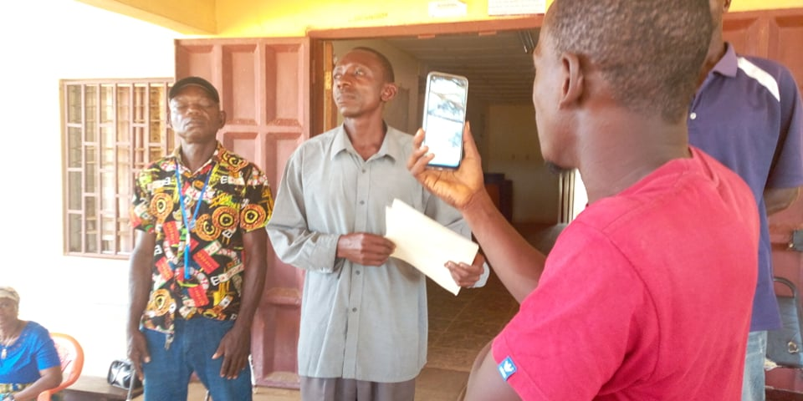

MR. BEYAN S. SIRYON, SECRETARY TO THE SUPERINTENDENT OF GBARPOLU COUNTY RECEIVED PETITION STATEMENT ON SRHR & RMNCH FROM CSOs ON THE GROUND OF THE ADMINISTRATIVE BUILDING OF GBARPOLU COUNTY, IN BOPOLU CITY ON JANUARY 10, 2022.

PETITIONNERS CHANTING SRHR & RMNCH SLOGAN ON THE GROUND OF THE ADMINISTRATIVE BUILDING OF GBARPOLU COUNTY, BOPOLU CITY ON JANUARY 10, 2022.

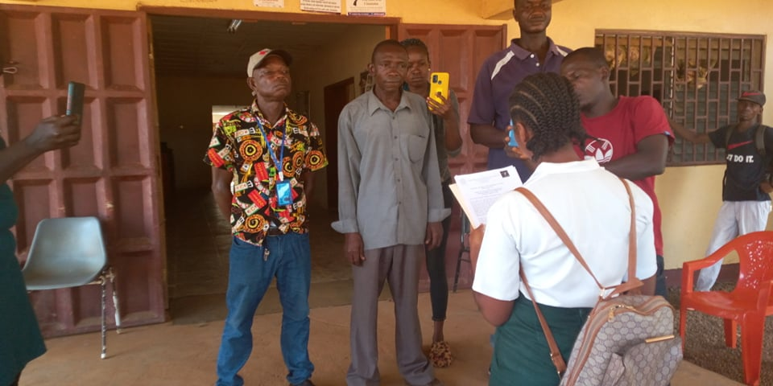


STUDENT AND ADOLESENT GIRLS ADVOCATE PRINCESS K. BAINDA OF THE BOPOLU CENTRAL HIGH SCHOOL (BCHS) READING PETITION STATEMENT TO MR. BEYAN S. SIRYON, SECRETARY TO THE SUPERINTENDENT OF GBARPOLU COUNTY RECEIVED PETITION STATEMENT ON SRHR & RMNCH FROM CSOs ON THE GROUND OF THE ADMINISTRATIVE BUILDING OF GBARPOLU COUNTY, IN BOPOLU CITY ON JANUARY 10, 2022.

PETITIONNERS PARADING WITH BANNER HAVING PROMOTIONAL SRHR & RMNCH INCRIPTIONS DURING THE PETITION ACTIONS IN GBARPOLU COUNTY, BOPOLU CITY ON JANUARY 10, 2022.

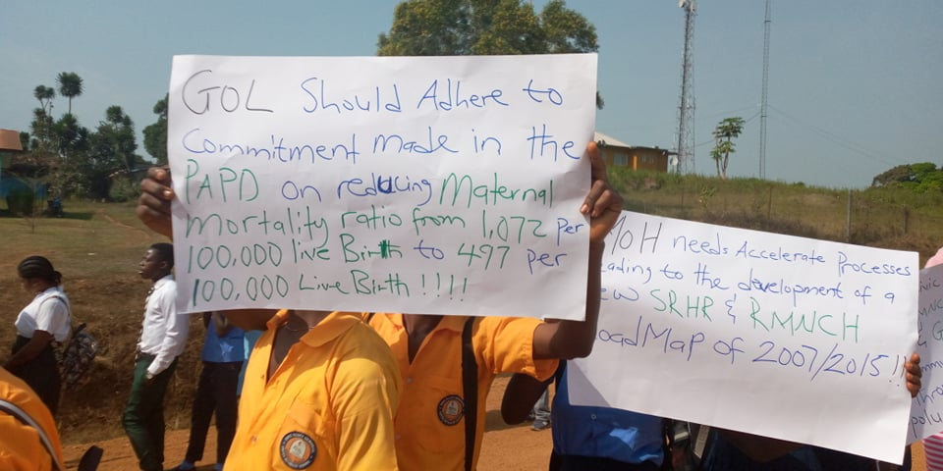


PETITIONNERS HOLDING PLACARDS WITH PROMOTIONAL SRHR & RMNCH INCRIPTIONS DURING THE PETITION ACTIONS AT GROUND OF THE ADMINISTRATIVE BUILDING OF GBARPOLU COUNTY, IN BOPOLU CITY ON JANUARY 10, 2022.

PETITIONNERS HOLDING PLACARDS WITH PROMOTIONAL SRHR & RMNCH INCRIPTIONS DURING THE PETITION ACTIONS AT GROUND OF THE ADMINISTRATIVE BUILDING OF GBARPOLU COUNTY, IN BOPOLU CITY ON JANUARY 10, 2022.



PETITIONNERS IN ATTENDANCE TO PETITION LOCAL AUTHORITY ON SRHR & RMNCH AT THE GROUND OF THE ADMINISTRATIVE BUILDING OF GBARPOLU COUNTY, IN BOPOLU CITY ON JANUARY 10, 2022.

PETITIONNERS CHANTING SRHR & RMNCH SLOGAN ON THE GROUND OF THE ADMINISTRATIVE BUILDING OF GBARPOLU COUNTY, IN BOPOLU CITY ON JANUARY 10, 2022.

