January 7, 2022
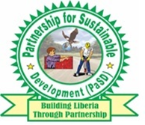
Partnership for Sustainable Development (PaSD)
One Day Petition Actions Report

Table of Contents:

Introduction………………………………………………………………………
Objective…………………………………………………………………………..
Methodology……………………………………………………………………
Petition statement presentation and responds from stakeholders……………………………………………………………………
Conclusion…………………………………………………………………………

Introduction:

The Partnership for Sustainable Development (PaSD) held One Day Petition Action under the project Action for Accelerating Sexual Reproductive Health Rights and Policy Implementation (AASPI) II funded by a British Charity, AmplifyChange on January 7, 2022 aimed at influencing decision of local authorities of |Grand Bassa County on the promotion of programs and policies on Reproductive, Maternal, New-born Child Health, Sexual Reproductive Health Right (SRHR and RMNCH) and Sexual Gender Based Violence (SGBV). The one day Petition Action took place at the ground of the Administrative Building of Grand Bassa County in Buchanan City. There were 50 petitioners at the petition ceremony representing women and children rights organizations, civil society organizations, community base organizations, faith base organizations, students, community leaders and dwellers and other relevant stakeholders from both sex, males representing 14% while females represents 76%.

Objectives:
The objective of the petition ceremony sought to demand local authorities policy decisions and actions to promote RMNCH and SRHR, county health team to influence national government to develop of a new roadmap on RMNCH and SRHR and to accelerate processes leading to the development of a new regime of the expired Investment Case of 2021 on Reproductive, Maternal, New-born Child Health, Sexual Reproductive Health Right (SRHR and RMNCH).

Methodology:
Before the conduct of the petition action in Grand Bassa County, PaSD along with collaborating organizations held specific working sessions to develop the petition statement. A committee of three was constituted to consolidate the information agreed during the working session into a statement and the draft were widely circulated to various collaborating civil society organizations for input before adoption. Several informative materials or papers were consulted in the development of the statements including briefing papers, factsheets, current and past National Budgets 2017/2018, 2018/2019, 2019/2020 and 2021/2021, the expired Investment Case for Reproductive, Maternal, Newborn Child and Adolescent Health in Liberia 2016/2021, the expired Roadmap for the Reduction of Maternal and Newborn Morbidity and Mortality in Liberia 2007/2015, the Abuja Declaration, Every Woman Every Child Initiative which demand countries to spend at least 10% of their National Health Budget to Maternal Newborn Child Health, Global Financing Facility under the stewardship of the World Bank and the UN Sustainable Development Goal 2030.
Project team along with the coalition program focus person had the responsibility to do the mobilization of the petitioners and each team was designated with responsibility to take petitioners to the petition venue to work with the leadership of civil society organizations, community leaders and dwellers, youth and women organizations were mobilized for the petition action. Communications were served to various leaderships, meetings were held with those leaderships and specific number of persons were assigned to each organization. The targeted were petitioned to make policy change decision to ensure the realization of project objectives were informed through appropriate communication inclusive the time, date, venue, what is expected of them and purpose of the petition ahead of time and follow ups were done through visiting the various offices of the targeted stakeholders. Placards were developed with SRHR and RMNCH promotional quotes.

Presentation of petition Statements by CSOs and Responds from Stakeholders:

During the petition actions at the grounds of the Administrative Building of Grand Bassa United Youth for Positive Change Executive Director-James L. King read and presented petition statement on behalf of the petitioners to Hon. Flee A. Glay, Development Superintendent of Grand Bassa County and Hon. Yassah V. Sumo, District Health Officer (DHO). The Petition Action took place on the ground of the Administrative Building of Grand Bassa County and was attended by 50 petitioners. Upon receipt of the petition statement, the Development Superintendent of Grand Bassa County appreciated the petitioners for the initiative and promised to present the statement to his colleagues that were not present. He also said; “while it is true that the issue of sexual reproductive health right is a challenge, there have been some work done through the county health team to improve the situation and further praise the CSOs of Grand Bassa County for their continuous advocacy around RMNCH ands |SRHR. He stated that the local authorities will accept the petition and will do everything to look into recommendations made by citizens and CSOs of the county in finding solution to this problem.

Recommendations:

- The Ministry of Health needs to ensure that 10% of the Ministry of Health Budget is directed to rape, Female Genital Mutilation, maternal, sexual, reproductive, child and adolescent health in adherence to every woman, every child initiative or the international conventional mandate of which Liberia has acceded to;
- Additionally, it is essential for the Ministry of Health to begin taking steps to ensure that the health component of the proposed 2023 National Budget and onward is increased to show the projections in Investment Case and commence the necessary process leading to the development of a new regime of the expiring Investment Case of 2021. adherence to the Abuja Declaration and reflect clear disaggregated lines on rape, Female Genital Mutilation, maternal, sexual, reproductive, child and adolescent health;
- There is a need for the Ministry of Health to accelerate processes leading to the development of a new roadmap for the reduction of maternal and newborn mortality and morbidity to replace the expired roadmap which expire since 2015;

Conclusion:
The one day petition action on SRHR and RMNCH organized by PaSD and collaborating CSOs in Grand Bassa County to national stakeholders was successfully held and we are expected to organize similar petition actions in other project counties as the implementation of the project goes on.

Pectoral view of participants at the one (1) Day Petition Action on SRHR/RMNCH

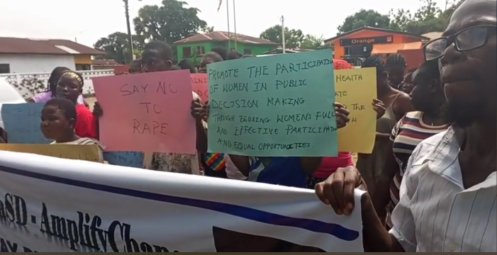
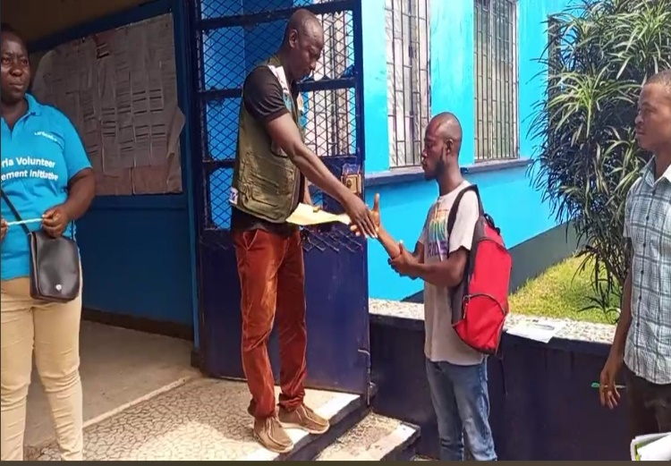

HON. FLEE A. GLAY, DEVELOPMENT SUPERINTENDENT OF GRAND BASSA COUNTY RECEIVING PETITION STATEMENT ON SRHR & RMNCH FROM CSOs ON THE GROUND OF THE ADMINISTRATIVE BUILDING OF GRAND BASSA COUNTY ON JANUARY 7, 2022.

PETITIONNERS CHANTING SRHR & RMNCH SLOGAN ON THE GROUND OF THE ADMINISTRATIVE BUILDING OF BUCHANAN CITY GRAND BASSA COUNTY ON JANUARY 7, 2022.

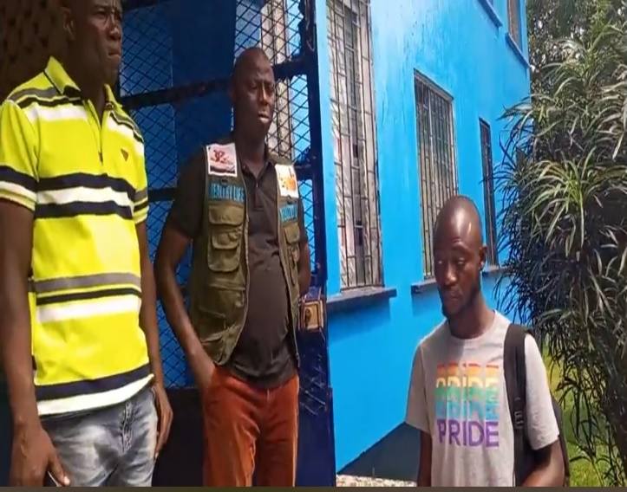
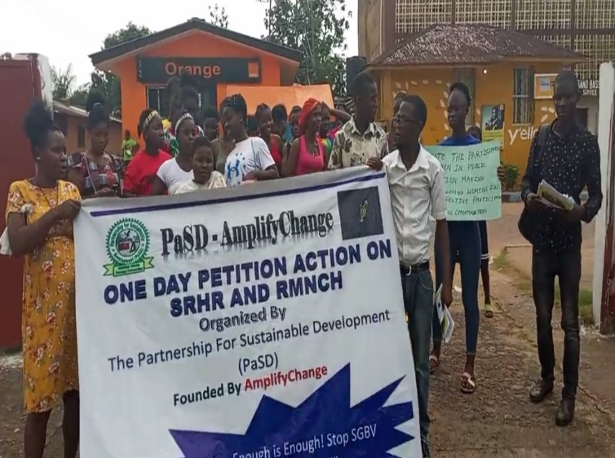

United Youth for Positive Change Executive Director-James L. King READING AND presented petition statement on behalf of the petitioners to Hon. Flee A. Glay ON THE GROUND OF THE ADMINISTRATIVE BUILDING OF BUCHANAN CITY GRAND BASSA COUNTY ON JANUARY 7, 2022.

PETITIONNERS PARADING WITH BANNER HAVING PROMOTIONAL SRHR & RMNCH INCRIPTIONS DURING THE PETITION ACTIONS IN BUCHANAN CITY GRAND BASSA COUNTY ON JANUARY 7, 2022.

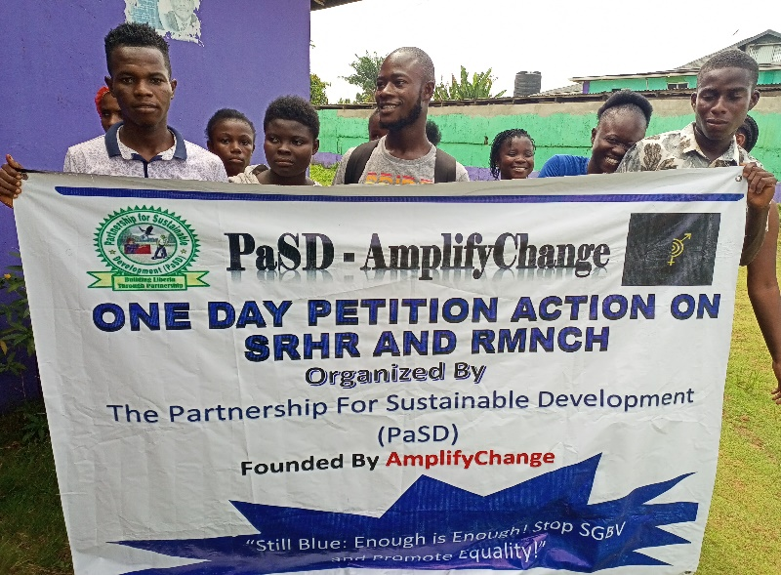
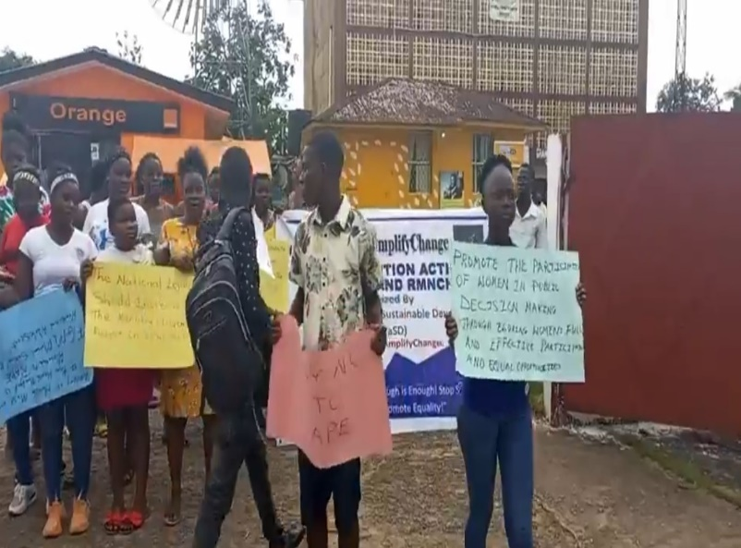

PETITIONNERS HOLDING PLACARDS WITH PROMOTIONAL SRHR & RMNCH INCRIPTIONS DURING THE PETITION ACTIONS AT GROUND OF THE ADMINISTRATIVE BUILDING OF GBARPOLU COUNTY, IN BOPOLU CITY ON JANUARY 10, 2022.

PETITIONNERS HOLDING BANNER WITH PROMOTIONAL SRHR & RMNCH INCRIPTIONS DURING THE PETITION ACTIONS IN GROUP PHOTO AT GROUND AT GROUND OF THE ADMINISTRATIVE BUILDING OF GBARPOLU COUNTY, IN BOPOLU CITY ON JANUARY 10, 2022.

