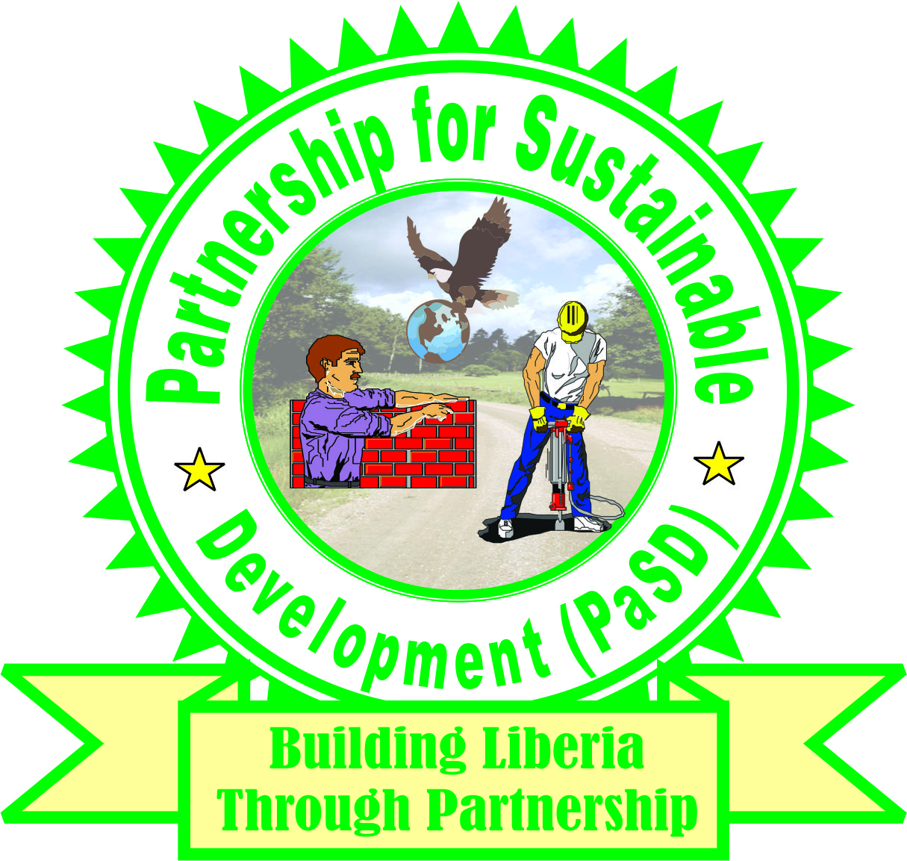
PaSD
Partnership for Sustainable Development
72nd Boulevard Road
Monrovia, Liberia

SAMLO-Spectacle of ArcelorMittal Liberia Operations

Report

December 3, 2021
- Introduction

After a lengthy renegotiation process throughout 2006, on 28th December 2006 the Government of Liberia and Mittal Steel signed an amended contract, which was passed into law by the Liberian Legislature in May 2007. The amended contract, gives Liberia a real chance of extracting reasonable benefits from the concession. The ongoing AML agreement relates only to iron ore and no other unspecified minerals. The right to additional minerals is reserved to the government and the governing law of the contract is in keeping with the Liberian Law.

The AML MDA in addition to mineral exploration contains Social obligations, such as free health care, education, housing, rail and port development, and jobs creation for Liberians and a requirement that ensures that within 5 years all senior managers will be Liberians.

After 52 weeks of negotiation between the government of Liberia and AML through the inter-ministerial concession committee (IMCC), the government of Liberia signed the AML MDA amendment deal on September 10, 2021. The proposed new MDA is valued at USD 800 Million, More than 2000 jobs are expected to be created during the construction phase, with Liberians envisaged to fill the majority of the roles created, With the increase in production volumes, the operations teams will also see a surge of about 1000 new jobs.

The expansion project encompasses processing, rail and port facilities development and therefore will be one of the largest mining projects in West Africa. It includes the construction of a new concentration plant and the substantial expansion of mining operations, with the first concentrate expected in late 2023, ramping up to 15 million tonnes per annum (‘mtpa’). Under the agreement the company will have reservation for expansion for at least up to 30mt. At these expanded levels, these iron ore expected to be exported will create a major boost to Liberia’s GDP.

Following President Weah’s submission of the AML MDA Amendment to the 54th national Legislature, some senior citizens and legislators of the three affected concession counties have been heard in the local media making claims that are deem inflammatory and inciteful against the company and could have the propensity to undermine the investment image of the company.

In an effort to inform discussions and decisions on the review and passage of the AML MDA Amendment, PaSD commissioned a desk review of related literature based on which this report is derived. This report contains the history of AML, brief history of the research organization, summary of the old and proposed deal, research methodology, scope and limitation of the research, finding and policy recommendations.

- Brief History of PaSD:

The Partnership for Sustainable Development (PaSD) formerly Citizens United to Promote Peace and Democracy in Liberia (CUPPADL) is a pro-democracy, peace building, human rights, policy, and development advocacy civil society organization. The PaSD started working in Liberia since 2003, later obtained incorporation document from the Ministry of Foreign Affairs on November 9, 2005, and certificate of accreditation from the defunct Ministry of Planning and Economic Affairs in 2009 renewed by the Ministry of Finance and Development Planning 2017 and 2019.

After several years of interventions in the health, water and sanitation, public financial management, natural resource and concession, civil society and governance sectors of Liberia, PaSD has been able to influence increase civil society participation in public policy formulation, implementation, and deliverance of basic social services. Additionally, the PaSD advocacy has contributed significantly to the improvement of the policy and governance environments, service quality and access of the population to basic social services such as health, water, and sanitation, public finance, Natural Resources and concession social funds etc.

Vision Statement:
PaSD vision a Liberia where every person basic social, economic, political and cultural rights are progressively realized and responsibilities fulfilled

Mission Statement:
PaSD mission is to contribute to the development of Liberia through supporting poor, marginalized and disadvantaged population claim their basic human rights and fulfill responsibilities in public governance, natural resource management, WASH, health and ensuring a stable environment

Thematic Program Areas of Focus
- Good Governance
- Human Rights and Justice
- Natural Resources
- Water and Sanitation
- Health
- Advocacy
- Peace Building

- Methodology
The methodology included a review of related literatures by a team of 4 (four) staffs of the research organization which included the Executive Director, The program officer, program Assistant, communication and Advocacy manager. Those related literatures were gathered from the internet, AML achieves, the Legislature, ministry of Finance and Development planning, Ministry of Mines and Energy amongst others. Three days working section were planned and implemented at which time the gathered related literatures were reviewed, analysed, data and information collected summarized into this report.
2.0 Scope and Limitation
The research lasted for a period of seven days and data and information were only collected from relevant literatures gathered from Monrovia. Due to resource and logistical limitation, the research was not designed to reach out to citizens of the concession affected counties of Bong, Nimba and Grand Bassa.

3.0 List of Documents Reviewed
The following documents were diligently reviewed
- The AML MDA of 2006
- Global witness statement on AML MDA and Operations
- Mongabay Article published in December on the AML Operations
- Official Data on the AML impact
- AML Accomplishment over the last 15 years of operations
- Gains of AML operations
- Q&A of the National Legislators Engagement

4.0 Findings:

Following a seven days comprehensive review of related literatures, our research team found several vital information about the performance of 2006 AML MDA and the 2021 proposed amendment. As you will see in the findings below, the 2006 AML MDA covered the first eight (8) counts (1-8) while the proposed amendment covered the last five (5) counts (9-13):

The Current AML Mineral Development Agreement

- AML is the First Major Investor in post-war Liberia in 2006: ArcelorMittal, the world’s leading steel and mining company presence in Liberia sends a strong statement to the markets and the world. The moment the company decided to invest a billion-dollar in our struggling economy, the company action in our view, sends a strong message to the global investment community that Liberia is a save and good place to do serious business.

- Employment: our desk review of related literatures found out that, hiring by AML and its contractors began in 2007. By 2008, some 3,000 local people were already employed both directly and indirectly through construction projects, records reveal. According to documentary evidence, the 2008 employment number surged in 2013 largely due to a Phase 2 construction work. This construction work is said to be responsible for increase in local jobs on the concession to 5000.

- Health Care and Educational Services: our desk review of related documents clearly shows that AML in keeping with article X section 1 and article XI section 1, 2 & 3 provided healthcare and educational services including the rehabilitation and reopening of two hospitals and schools respectively in Yekepa and Buchanan to provide medical care and educational services to both employees and local residents rather than just employees, their spouses, dependents, children and government officials assigned in the concession operational areas as required by the MDA. Meanwhile, documents in the possession of PaSD reveal additionally that AML in keeping with the article XI section 1 b, reimbursed parents in Buchanan for their children’s school tuition.

Meanwhile, the organizational desk review of vital documents discovered that AML has spent US $1.7 million on foreign scholarship program that has benefitted 29 qualified Liberian citizens to pursue advanced studies abroad in keeping with article XI section 2 b & c. Additionally, we were able to uncover that AML MDA was ambiguous, did not clearly specify weather the foreign scholarship should be awarded directly to concession counties citizens. Rather, the MDA ambiguously put it at “qualify Liberians”.

In keeping with article XI section 2 b, AML over the years has also supported T-VET program through the rehabilitation and reopening of the Yekepa Vocational Training Center (YVTC) in 2017. AML is said to have spent US $7 million to refurbish the YVTC state-of-the-art training facility. The facility to date has an enrolment of approximately 159 students and first batch of 45 recently graduated in 2021.

Ebola and COVID-19 Outbreaks: we found out that, AML worked extensively with the Ministry of Health and other companies operating in the subregion to control the spread of the EVD and COVID-19 diseased in West Africa with financial and in-kind donations as well as lobbying international partners like WHO and in the case of EVD the US Government, whose military contingent played a huge role in eradicating the disease.

- Development of infrastructure, Energy and Liberia begins Exportation Again: The organization desk review of related literature additionally found out that AML rehabilitated rail and port infrastructure and constructed new mine facilities at Tokadeh thereby facilitating the restart of iron ore exports from Liberia in 2011, which saw the first shipment of ore from the country after more than 20 years.

Ganta Yekepa Highway: AML has made a US $40 million commitment to fund the paving of the Ganta Yekepa road corridor in Nimba County. This corridor key section between Ganta and Sanniquellie is expected to be completed in mid-2022. The people of Nimba had complained that LAMCO had not built this highway during its decade’s long operations in Liberia.

Energy: we found out that, when ArcelorMittal entered Liberia in 2005, the country had no electricity especially in the operations areas other than private generators. Together with the then Ministry of Lands, Mines and Energy, World Bank and ECOWAS, AML participated in national effort towards connecting the country with the WAPP line in Cote D’Ivoire for the provision of electricity. This project is depending on AML heavily, being a large offtaker of electricity and accordingly the line has been routed via Yekepa and Buchanan.

- EITI Liberia Report: Records showed that ArcelorMittal Liberia had been in full compliance with Liberia’s EITI regulation through reporting its payments to Government, which was key in making the country the first in Africa to comply with the Global Extractive Industries Transparency Initiative (EITI).

- Corporate Social Responsibilities: current records show that in keeping with Article XIV of AML MDA, the company has been regularly remitting US $3 million annually for the counties in which it operates. To date, according to records, the company has paid $45 million towards CSDF commitment in the MDA. Additionally, in an effort to ensure citizens of concession communities complaints that the CSDF were not benefiting the affected communities, AML lobbied the Government of Liberia to ensure 20% of CSDF be managed directly by communities, a request which successfully kicked off in 2020.

- Environmental Protection and Management: the MDA Article XV outlined measures for the company’s protecting, preserving and promoting the environment. In this regard ArcelorMittal made biodiversity an important element of the its operating strategy in Liberia. Some of the country’s most accessible iron ore deposits are found in the remote Nimba mountain range, which is also one of West Africa’s few remaining wet-zone forests and home to many rare species. Conscious of minimising disruption to these fragile ecosystems, ArcelorMittal in adherence to Article XV, Section 1 convened a team of non-governmental organisations, international conservation groups and governmental stakeholders including the Liberian Forestry Development Authority, Conservation International, Flora & Fauna International and the Côte d’Ivoire-based Afrique Nature. The resulting year-long ecological study highlighted both the fragility of this environment and also the potential for ArcelorMittal to not only mitigate further ecological damage to the region, but indeed to start reversing this history of decline.

- Safety: AML’s commitment to the safety of communities are:

a) As part of the railroad rehabilitation, our study suggest that an ongoing safety programme has aims to educate those communities that border the railway, many of which have not experienced rail traffic in 20 years. This Road and Rail awareness campaign uses street theatre to educate local communities on safety issues. The street theatre campaign is said to be conducted both in English and local languages and has so far reached 23 of the larger local communities as well as local schools where puppet shows are used to raise awareness.

b) In 2010, our study found out that with the overall aim to reduce the number of road accidents, safety activities were extended to supporting the Liberia National Police in running three workshops on road safety. The workshops brought together 300 taxi drivers, commercial motorcycle operators, transport union officials, and local authorities in Grand Bassa, Bong and Nimba.
4.2 AML Amendment and the New Deal

- The New AML MDA to which passage is sought from the National Legislature, we observe is the First Major Investment in Liberia since the departure of UNMIL, first Major Expansion of Existing Company in the country’s post-war history and first major investment after the successive political transition in Liberia. we view the ArcelorMittal’s commitment to invest $800 million in the country under the new MDA as welcoming development that every Liberian must embrace and we think this action will sent a strong message to the Global investment community that Liberia is safe for investment especially in the absent of international troops. The AML new deal in our view, could rekindle the fragile investment climax and buster confidence for foreign direct investment in the country.

- Employment: More emphasis must be placed on the more than 2000 jobs that are expected to be created during the construction phase, with Liberians envisaged to fill the majority of the roles created. We found out additionally that, with the increase in production volumes, under the New Deal, the AML operations teams will also see a surge of about 1000 new jobs.

- Liberia becomes major iron ore producer: our review of the AML propose New MDA shows that the expansion requested encompasses processing, rail and port facilities development. The project is one of the largest mining projects in West Africa. It includes the construction of a new concentration plant and the substantial expansion of mining operations, with the first concentrate expected in late 2023, ramping up to 15 million tonnes per annum (‘mtpa’). Under the agreement the company will have reservation for expansion for at least up to 30mt. At these expanded levels, these iron ore exports will create a major boost to Liberia’s GDP. We believe rather than concentrating our denigrating the company and the small errors, policy makers and leaders of the country must look at these bigger pictures.

- ArcelorMittal technology for concentration: our review of the propose MDA found out that, under the expansion, the company seeks to use its proprietary knowledge to produce a high-quality concentrate, utilizing the available deposits in the concession area. While the bulk of iron ore found in Liberia cannot be sold as DSO (i.e. without processing), AML’s commit in the new deal to build these concentrators adds significant value to Liberia’s natural resources.

- On Debate of the New Deal closed Rail and Port to other users: we found out that, the agreement strengthens GoL’s demand for other users including Guinean miners to utilize the Liberia infrastructure for their export. The expansion expresses the companies need to invest funds to increase the capacity of the rail and port for their own use. However, AML has committed to concluding a MultiUser Agreement with GoL after this agreement is ratified.

5.3 Policy Recommendations

- We believe, if there are some provisions of the ongoing AML MDA that have not been implemented, rather than calling for the rejection of the new deal and denigrating the company, policy makers, leaders and senior citizens should sit with the company, understand the reason(s) for the failure and determine genuine solution in the passage off the new deal

- We strongly hold the opinion that the many inflammatory statements in the press against the company’s operations especially from senior citizens and national leaders must be put to an immediate end largely because they have the propensity to incite citizens in concession areas into violence and non-cooperation actions. Something we think is counterproductive to national effort to attract investors to the country and these happening do not portray Liberia as an investment friendly environment and could scare away new foreign direct investment

- We want an end to the blame shifting and call on the Government and the AML to jointly review the Ebola and COVID-19 outbreaks to establish those incidents impact on the company, Government of Liberia operations and the full implementation of roles and responsibilities as outline in the ongoing MDA to inform decision and discussions on the performance of AML on the ongoing MDA and proposed new deal

- Rejection of the company’s request for expansion should not be an option for decision makers, leaders, senior and ordinary citizens of the concession areas and the country as doing so could cost us to loss 80 million in annual revenue, 3000 new employment, development of various infrastructure, the elevation of Liberia in the Global mining community amongst others

- We believe, the ambiguity in the rail, port, education, health and other clauses of the ongoing AML MDA must be mitigated in the proposed new deal. In this regard, policy makers, leaders, senior and ordinary citizens of the concession areas and the country must concentrate and strategically find ways of improving on those clauses in the propose new MDA rather than using same to spell negative propaganda about the company thereby causing the country’s investment image to be ruined.

